**Hindi Vidya Prachar Samiti’s**

**Ramniranjan Jhunjhunwala College of Arts, Science & Commerce**

**(Empowered Autonomous College)**



**Affiliated to**

**UNIVERSITY OF MUMBAI**

**DEPARTMENT OF INFORMATION TECHNOLOGY**

**2024-2025**

**M.Sc. (IT) part i SEM i**

**PAPER RJSPIT103P – Introduction to Data Science**

**Name :- Vishwakarma Shivam Suresh Sushila**

**Roll No. 6620**

**Hindi Vidya Prachar Samiti’s**

**RAMNIRANJAN JHUNJHUNWALA COLLEGE**

**Ghatkopar (W), Mumbai-400 086**

***Certificate***



**This is to certify that Mr./Ms. Vishwakarma Shivam Suresh Suhila Roll No 6620 of M.Sc.(I.T.) Part-1 class has completed the required number of experiments in the subject of Introduction to Data Science in the Department of Information Technology during the academic year 2024 - 2025 .**

**Professor In-Charge Co-ordinator of IT Department**

**Prof. Bharati Bhole**

#### **College Seal & Date Examiner**

#### **INDEX**

**Introduction to Data Science**

| **Sr. No.** | **Practical** | **Page no.** | **Date** |
| --- | --- | --- | --- |
| 1 | NumPy, Pandas, Matplotlib Basics. |  | Jul 16, 2024 |
| 2 | Collecting and loading structured and unstructured data  Load data from the following files into csv format.   1. Text delimited csv file to Python dataframe. 2. XML file to Python dataframe. 3. JSON file to Python dataframe 4. Picture to Python dataframe 5. Video to Python dataframe 6. MySQL database to Python dataframe |  | Aug 6, 2024 |
| 3 | Using Data pre-processing. for various types of data |  | Aug 10, 2024 |
| 4 | Basic utility design, Data auditing and Exploratory Data Analysis   1. Fixer Utilities |  | Aug 13, 2024 |
| 5 | Retrieve Superstep |  | Aug 13, 2024 |
| 6 | Access Superstep |  | Aug 20, 2024 |
| 7 | Processing Data |  |  |
| 8 | Data Visualization / Report Superstep |  | Aug 20, 2024 |
| 9 | Data Analysis using Excel |  | Aug 20, 2024 |

#### **PYTHON REVISION**

Jul 23, 2024

**Q] Write a python code to store the given values in tuples and display in the given format by using the user defined function named 'printString'**

| tup1 = ("Amit", 45, "TY")  tup2 = ("Sumit", 25, "SY")  tup3 = ("Anita", 24, "FY")  template = "{0:s} has {1:.2f}% in the class {2:s}"  print("Template string : ", template)  def printString(str, tup):  print(str.format(tup[0], tup[1], tup[2]))  listTuple = [tup1, tup2, tup3]  for item in listTuple:  printString(temp, item) |
| --- |

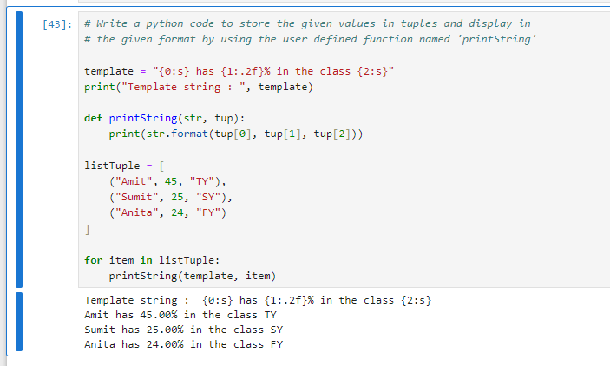

**Q] Write a python code to store and display the square of odd numbers upto 10. Generate the odd number using the range function.**

| list = []  for i in range(1, 10, 2):  list.append(i*i)  print(list) |
| --- |

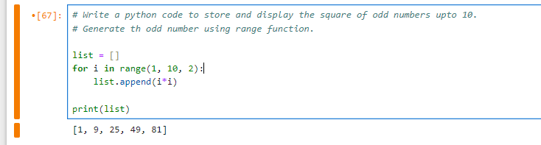

**Q] Create a python dictionary from the given sequences.**

Sequences:

keyList =['fy','sy',ty']

vlaueList=[[1,2,3],[4,5,6],[7,8,9]]

Expected dictionary output:

{'fy':[1,2,3],'sy':[4,5,6],'ty':[7,8,9]}

1. Display the list of keys of the resultant dictionary
2. Display the list of values of the resultant dictionary
3. Change the values of 'ty' to 11,21,31 using update() function
4. Get the value of 'sy' key by using pop() function

| keyList =['fy','sy','ty']  valueList=[[1,2,3],[4,5,6],[7,8,9]]  myDict = {}  for key, value in zip(keyList, valueList):  myDict[key] = value  print("Dict : ", myDict)  print("keys : ",myDict.keys())  print("values : ", myDict.values())  myDict.update({'ty':[11,21,31]})  print("Dict after updation : ", myDict)  print("Dict after popping 'sy' : ", myDict.pop('sy')) |
| --- |

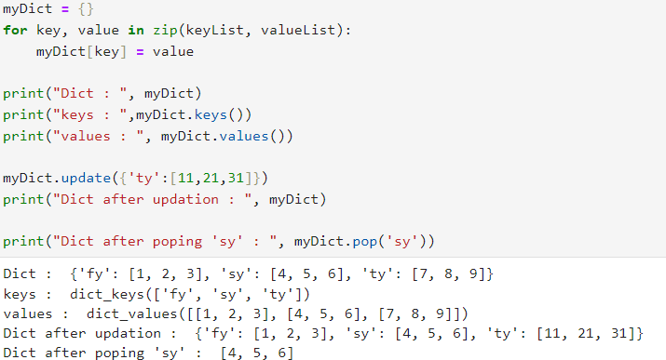

**Q] For the following data create the dictionary of the alphabet bitwise list of fruits.**

Data: ['apple','banana','blue berry','apricot','orange','pine apple']

Expected output:{a:['apple','apricot'],'b':['banana','blue berry'],'o':'orange','p':'pine apple']}

| fruits = ['apple', 'banana', 'blue berry', 'apricot', 'orange', 'pine apple']  fruitDict = {}  for fruit in fruits:  letter = fruit[0]  if letter not in fruitDict:  fruitDict[letter] = [fruit]  else:  fruitDict[letter].append(fruit)  fruitDict |
| --- |

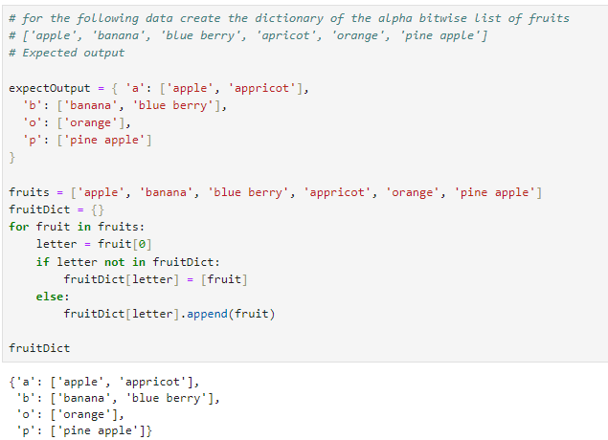

**Bytes**

* Represent raw data, like images, audio, or text encoded in a specific way.
* Sequences of 8-bit values (0-255).
* Eg : b'hello'.

**Unicode**

* Represent text in a universal way, supporting characters from all languages.
* Sequences of Unicode code points.
* Created using the str type: 'hello'.

**Encoding and Decoding**

* To convert Unicode strings to bytes, use the encode() method with a specific encoding like UTF-8: **'hello'.encode('utf-8')**
* To convert bytes to Unicode strings, use the decode() method with the appropriate encoding: **b'hello'.decode('utf-8')**

| str = "6620_Shivam"  print("str data type: ", type(str))  encode_str = a.encode('utf-8')  print("\nEncoded str : ", encode_str)  print("Encoded str Data type : ", type(encode_str))  decode_str = b.decode('utf-8')  print("\nDecode str : ", decode_str)  print("Decode str Data type : ", type(decode_str)) |
| --- |

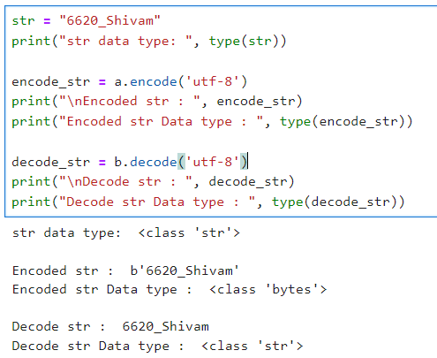

**zip()** : zip “pairs” up the elements of a number of lists, tuples, or other sequences to create a list of tuples

| roll_no = [6620, 6621, 6622]  name = ["Shivam","Random","Other"]  print("Zipped : ", list(zip(roll_no, name))) |
| --- |

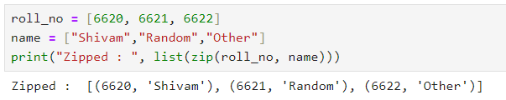

**Q] Set operations**

| # Define sets a and b  a = {1, 2, 3, 4, 5}  b = {3, 4, 5, 6, 7, 8, 9}  # Print the initial sets  print('a : ', a)  print('b : ', b)  # Adds an element to the set  a.add(8)  print('a.add(8) : ', a)  # Removes a specific element from the set  a.remove(4)  print('a.remove(4) : ', a)  # Removes and returns an arbitrary element from the set  # You cannot predict which element will be removed  a.pop()  print('a.pop() : ', a)  # New set containing all elements from set a and set b  print('a.union(b) : ', a.union(b))  # Adds all elements from set b to set a  a.update(b)  print('a.update(b) : ', a)  # New set containing elements that are common to both sets  print('a.intersection(b) : ', a.intersection(b))  # Updates set a to contain only elements that are common to both sets a and b  a.intersection_update(b)  print('a.intersection_update(b) : ', a)  # New set containing elements that are in set a but not in set b  a.difference(b)  print('a.difference(b) : ', a)  # Updates set a to remove elements that are also in set b  a = {1, 2, 3, 4, 5}  a.difference_update(b)  print("a.difference_update(b)) : ", a)  # New set containing elements that are in either set a or set b but not in both  print("a.symmetric_difference(b) : ", a.symmetric_difference(b))  # Updates set a to contain elements that are in either set a or set b but not in both  a.symmetric_difference_update(b)  print("a.symmetric_difference_update(b) : ", a)  # Checks if all elements of set a are contained in set b  print("a.issubset(b) : ", a.issubset(b))  # Checks if set a contains all elements of set b  print("a.issuperset(b) : ", a.issuperset(b))  # Checks if sets a and b have no elements in common  print("a.isdisjoint(b) : ", a.isdisjoint(b)) |
| --- |

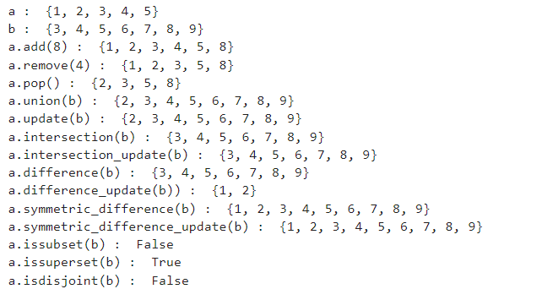

**Q] From the given list sum the elements that are greater than 10.**

Eg - 8,9,11,23,34,10

| listvar=[8,9,11,23,34,10]  sum([x for x in listvar if x > 10]) |
| --- |

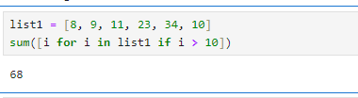

**Q] For the given list of strings store the length of each string into a set variable.**

Ex - 'Bharati','Aasha','Easy','Code'

| strList = ["Bharati", "Aasha", "Easy", "Code"]  set(len(item) for item in strList) |
| --- |

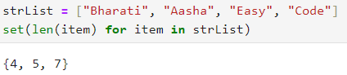

**Q] for the given list of numbers calculate the square and cube by using a user defined function named calculate()**

Ex 34,45,56

| def calculate (numList):  square = [item*item for item in numList]  cube = [item*item*item for item in numList]  return square, cube  numList = [34,45,56]  square, cube = calculate(numList)  print("Square : ", square)  print("Cube : ", cube) |
| --- |

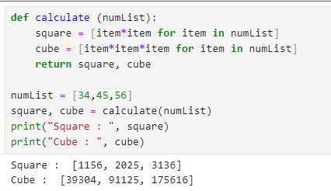

**Q]Count the length of list and store it in Dictionary**

| object = ["Apple", "Bat", "Chicken", "Dumpyard", "Erangel", "Friangi"]  objectLen = dict()  for item in object:  objectLen[item] = len(item)    objectLen |
| --- |

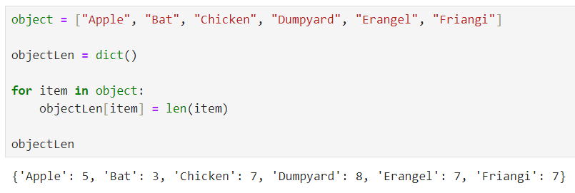

**Regular Expression**

| import re  name = [".Manish ", " Hardik4!", "Akshay#$", "Shreelaxmee!", "12Rohan", "An jana"]  def clean_strings(strings):  result = []  for value in strings:  value = value.strip()  value = re.sub('[ !$#?.0-9]', '', value)  value = value.title()  result.append(value)  return result    clean_strings(name) |
| --- |

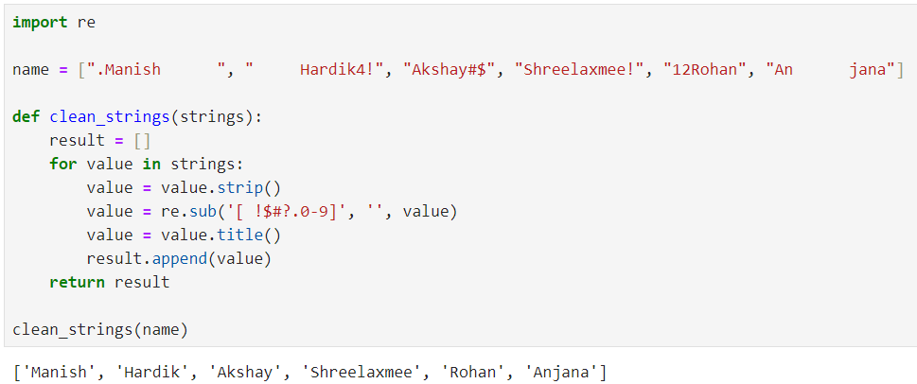**lambda**

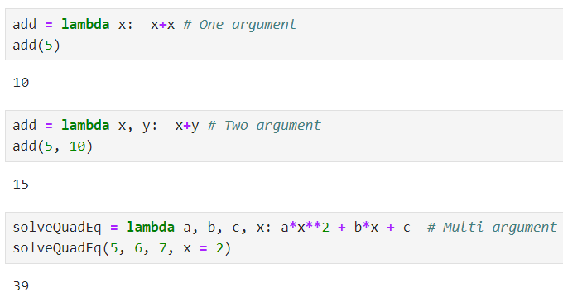

#### 

#### **Practical 1 - NumPy, Pandas, Matplotlib and Seaborn Basics**

Jul 16, 2024

**JupyterLite** → <https://jupyter.org/try-jupyter/lab/>

##### **NUMPY**

* NumPy is a Python library used for working with arrays.
* It also has functions for working in the domain of linear algebra, fourier transform, and matrices.
* NumPy was created in 2005 by Travis Oliphant. It is an open source project and you can use it freely.
* NumPy stands for Numerical Python.
* NumPy aims to provide an array object that is up to 50x faster than traditional Python lists.
* The array object in NumPy is called ndarray, it provides a lot of supporting functions that make working with ndarray very easy.

**Ndarray Basic Operations**

1. **array() :** used to create an array object from a sequence such as a list, tuple or another array-like structure.
2. **arange()** : used to create arrays with evenly spaced values within a given range

**syntax :**

numpy.arange([start, ]stop, [step, ]dtype=None)

1. **reshape()** : creates a new view of the array with a different shape. The total number of elements in the original array must match the total number of elements in the reshaped array.
2. **a.shape** : Returns the shape of the array, which is a tuple representing the size of the array along each dimension.
3. **a.ndim** : Returns the number of dimensions (axes) of the array.
4. **a.dtype** : Returns the data type of the array's elements as a numpy.dtype object.
5. **a.dtype.name** : Returns the name of the data type of the array's elements as a string.
6. **a.itemsize** : Returns the size (in bytes) of each element in the array.
7. **type(a)** : Returns the type of the object a

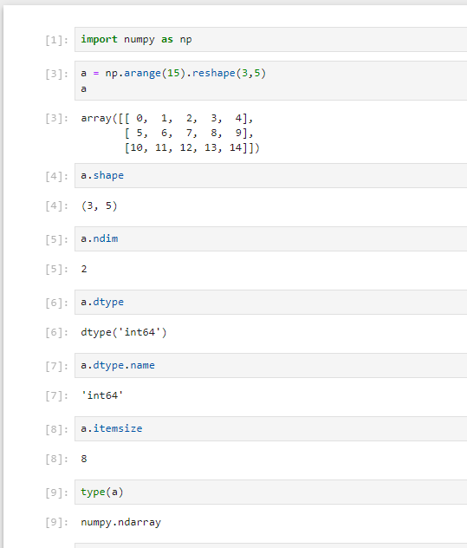

**Array Creation**

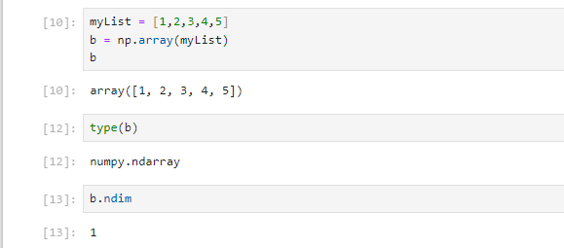

**Changing Array Dimension**

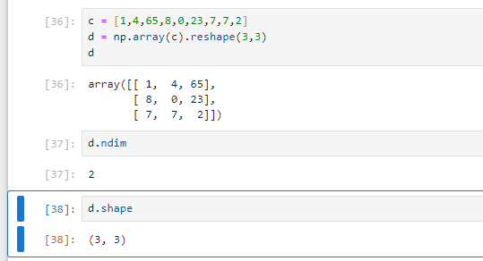

**Array using tuple**

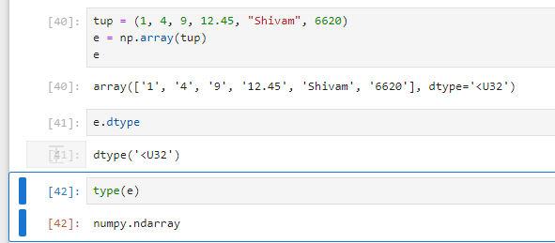

**2D array**

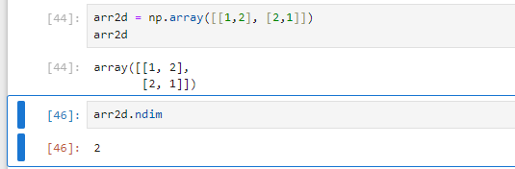

**3D array**

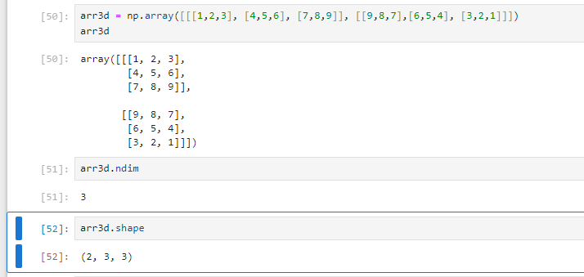

**Accessing array elements**

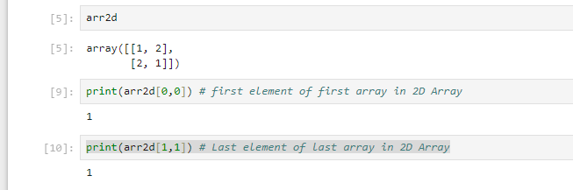

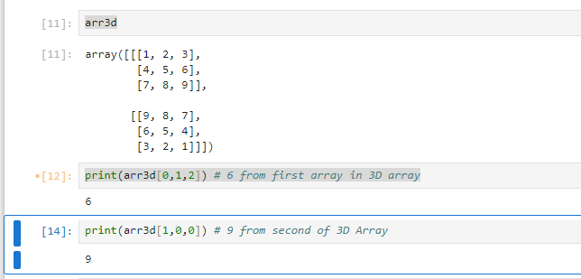

**Multidimensional array**

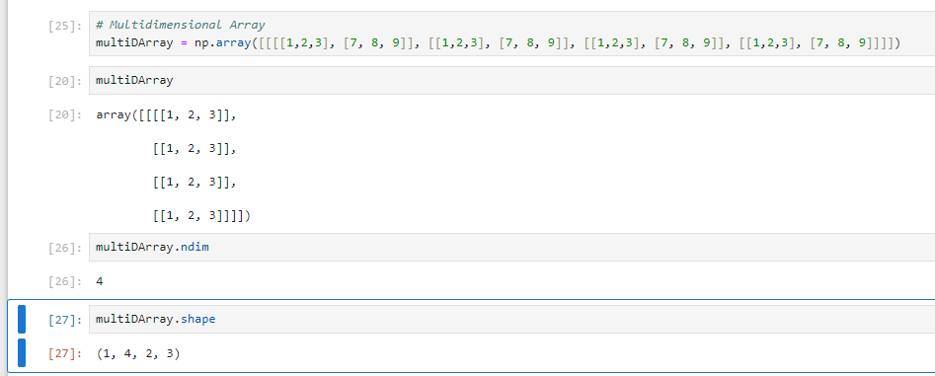

**Slicing an array**

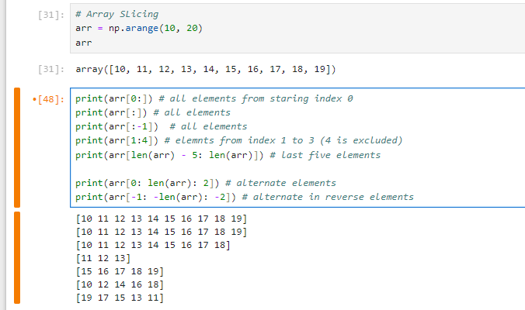

**Creating identity and random matrix**

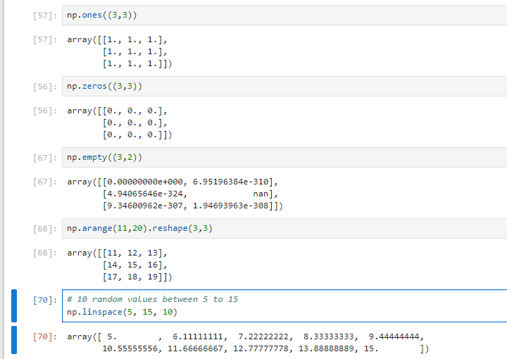

**Array in Trigonometric**

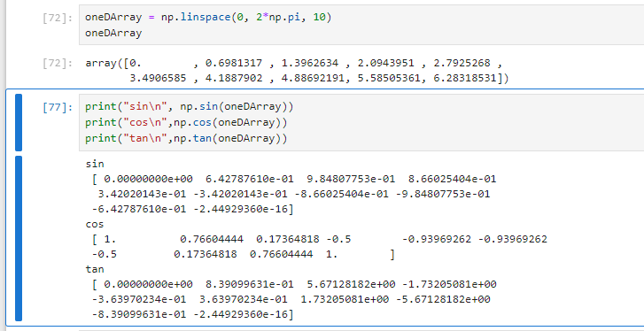

**Array Creation**

1. **np.arange([start], stop, [step])**: Creates an array with values from start to stop (exclusive), with a specified step size between values.
2. **np.array(object)**: Converts the input object (like a list or tuple) into a NumPy array, with optional type specification.
3. **np.copy(a)**: Creates a new copy of the array a.
4. **np.empty(shape)**: Creates an array with the specified shape and data type, without initializing the entries.
5. **np.linspace(start, stop, num=50)**: Creates an array with num evenly spaced values between start and stop.
6. **np.identity(n)**: Creates an identity matrix of size n x n.
7. **np.ones(shape)**: Creates an array filled with ones, with the specified shape.
8. **np.zeros(shape)**: Creates an array filled with zeros, with the specified shape.

**code**

| import numpy as np  arr_arange = np.arange(0, 10, 2)  print("arange:", arr_arange)  arr_array = np.array([1, 2, 3, 4, 5])  print("\narray:", arr_array)  arr_copy = arr_array.copy()  print("\ncopy:", arr_copy)  arr_empty = np.empty((2, 3))  print("\nempty:\n", arr_empty)  arr_linspace = np.linspace(0, 1, 5)  print("\nlinspace:", arr_linspace)  arr_identity = np.identity(3)  print("\nidentity:\n", arr_identity)  arr_ones = np.ones((2, 3))  print("\nones:\n", arr_ones)  arr_zeros = np.zeros((2, 3))  print("\nzeros:\n", arr_zeros) |
| --- |

**Output**

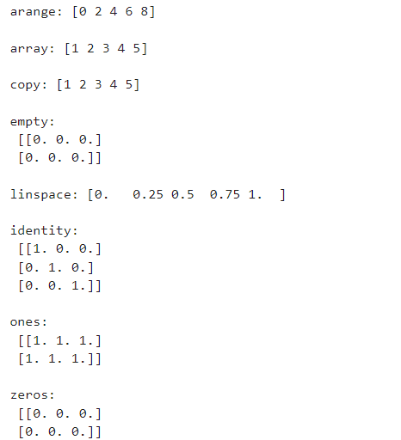

**Conversion**

1. **ndarray.astype(dtype)**: Converts the array to the specified data type.
2. **np.atleast_1d(arys)**: Converts inputs to arrays with at least one dimension.
3. **np.atleast_2d(arys)**: Converts inputs to arrays with at least two dimensions.
4. **np.atleast_3d(arys)**: Converts inputs to arrays with at least three dimensions.
5. **np.mat(data)**: Converts the input data to a matrix.

**code**

| import numpy as np  arr_array = np.array([1, 2, 3])  arr_float = arr_array.astype(float)  print("astype:", arr_float)  arr_atleast_1d = np.atleast_1d([1, 2, 3])  print("\natleast_1d:", arr_atleast_1d)  arr_atleast_2d = np.atleast_2d([1, 2, 3])  print("\natleast_2d:\n", arr_atleast_2d)  arr_atleast_3d = np.atleast_3d([1, 2, 3])  print("\natleast_3d:\n", arr_atleast_3d)  arr_mat = np.mat([[1, 2], [3, 4]])  print("\nmat:\n", arr_mat) |
| --- |

**Output**

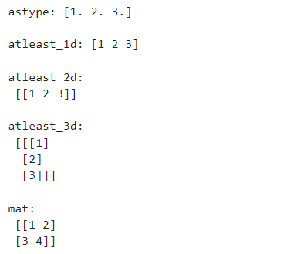

**Manipulation**

1. **np.array_split(ary, indices_or_sections)**: Splits an array into multiple sub-arrays.
2. **np.concatenate((a1, a2, ...), axis=0)**: Joins a sequence of arrays along a specified axis.
3. **np.diag(v)**: Extracts or constructs a diagonal array.
4. **ndarray.item(index)**: Returns the element at the specified index as a standard Python scalar.
5. **ndarray.reshape(new_shape)**: Reshapes the array to a new shape without changing the data.
6. **np.resize(a, new_shape)**: Resizes the array to a new shape, possibly changing its size.
7. **ndarray.T**: Returns the transpose of the array (i.e., switches rows and columns).

**code**

| import numpy as np  arr_array = np.array([1, 2, 3, 4, 5, 6])  arr_split = np.array_split(arr_array, 3)  print("array_split:", arr_split)  arr_concatenate = np.concatenate([arr_array, arr_array])  print("\nconcatenate:", arr_concatenate)  arr_diag = np.diag([1, 2, 3])  print("\ndiagonal:\n", arr_diag)  arr_item = arr_diag.item(4)  print("\nndarray.item:", arr_item)  arr_reshape = arr_array.reshape((2, 3))  print("\nreshape:\n", arr_reshape)  arr_resize = np.resize(arr_array, (2, 3))  print("\nresize:\n", arr_resize)  arr_transpose = arr_diag.T  print("\ntranspose:\n", arr_transpose) |
| --- |

**Output**

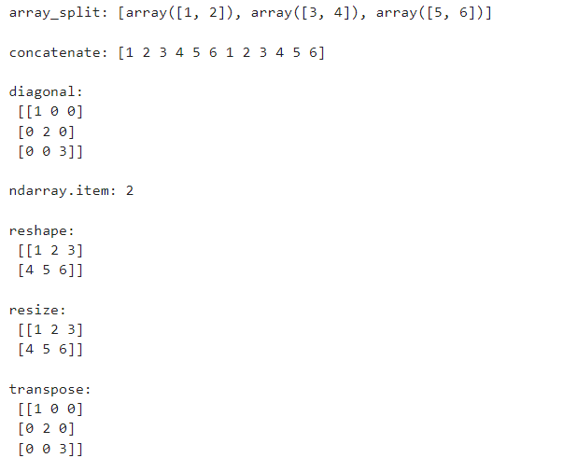

**Basic Statistics**

1. **np.cov(m)**: Computes the covariance matrix of the input array.
2. **np.mean(a, axis=None)**: Calculates the arithmetic mean of the array elements.
3. **np.std(a, axis=None)**: Computes the standard deviation of the array elements.
4. **np.var(a, axis=None)**: Computes the variance of the array elements.

**code**

| import numpy as np  arr_cov = np.cov([[1, 2, 3], [4, 5, 6]])  print("cov:\n", arr_cov)  arr_array = np.array([1, 2, 3, 4, 5])  arr_mean = np.mean(arr_array)  print("\nmean:", arr_mean)  arr_std = np.std(arr_array)  print("\nstd:", arr_std)  arr_var = np.var(arr_array)  print("\nvar:", arr_var) |
| --- |

**Output**

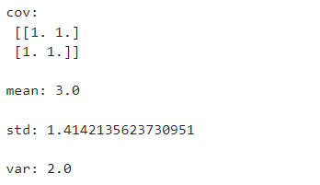

**Operations**

1. **np.sum(a, axis=None)**: Computes the sum of array elements.
2. **np.cumsum(a, axis=None)**: Computes the cumulative sum of array elements.
3. **np.prod(a, axis=None)**: Computes the product of array elements.
4. **ndarray.put(indices, values)**: Sets the specified indices of the array to the given values.
5. **np.compress(condition, a, axis=None)**: Filters elements of an array based on a condition.

**code**

| import numpy as np  arr_sum = np.sum([1, 2, 3, 4, 5])  print("sum:", arr_sum)  arr_cumsum = np.cumsum([1, 2, 3, 4, 5])  print("\ncumsum:", arr_cumsum)  arr_prod = np.prod([1, 2, 3, 4, 5])  print("\nprod:", arr_prod)  arr_array = np.array([1, 2, 3, 4, 5])  arr_put = arr_array.copy()  arr_put.put([0, 2], [10, 20])  print("\nput:", arr_put)  arr_compress = np.compress([1, 0, 1, 0, 1], [10, 20, 30, 40, 50])  print("\ncompress:", arr_compress) |
| --- |

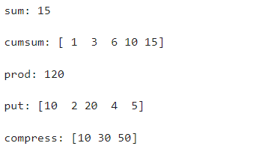

**Basic Algebra**

1. **np.cross(a, b)**: Computes the cross product of two vectors.
2. **np.dot(a, b)**: Computes the dot product of two arrays. For 2-D arrays, it performs matrix multiplication.

**code**

| import numpy as np  arr_cross = np.cross([1, 0, 0], [0, 1, 0])  print("cross:", arr_cross)  arr_dot = np.dot([1, 2, 3], [4, 5, 6])  print("\ndot:", arr_dot) |
| --- |

**Output**

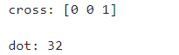

##### **PANDAS**

* Pandas is a Python library used for working with data sets.
* It has functions for analyzing, cleaning, exploring, and manipulating data.
* Pandas allows us to analyze big data and make conclusions based on statistical theories.
* Pandas can clean messy data sets, and make them readable and relevant.

**Series:** A one-dimensional array-like object containing a sequence of values and an associated array of data labels, called its index.

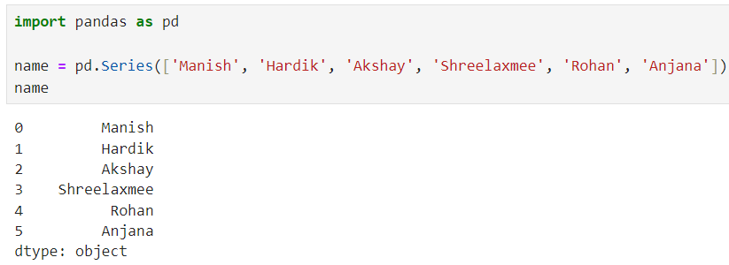

**index parameter:** to specify your own index

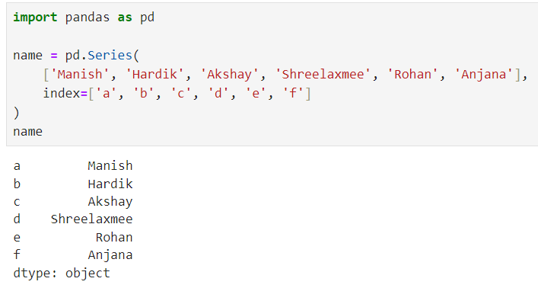

**DataFrame :** A Pandas DataFrame is a 2 dimensional data structure, like a 2 dimensional array, or a table with rows and columns.

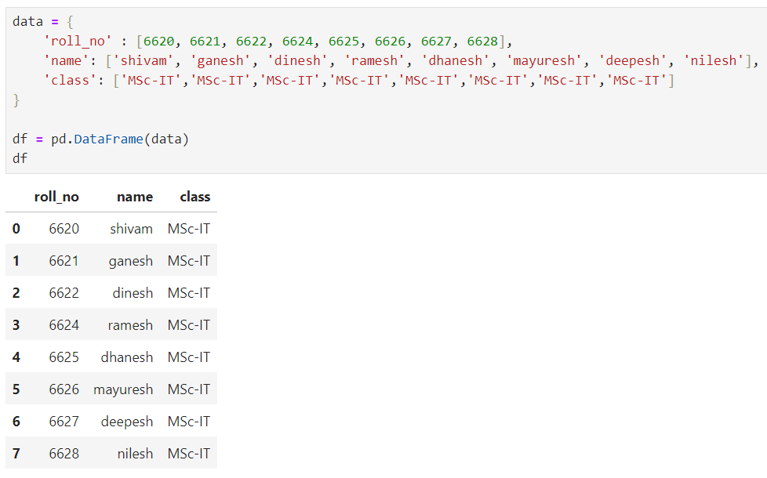

**head() and tail() :** default return 5 row from dataframe

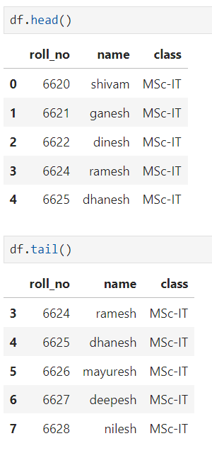

By giving no as argument can get that no of rows you want to retrieve

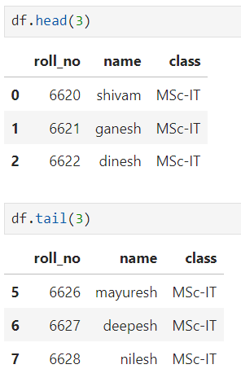

**describe() :** gives descriptive statistics such as mean, standard deviation, minimum, maximum, and quartiles for numerical columns in a DataFrame.

returns DataFrame containing the summary statistics for each numerical column

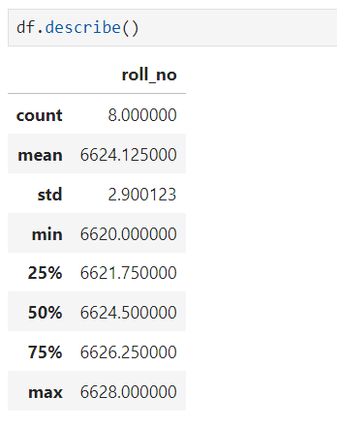

**dtypes** : gives information about the data types of each column in a DataFrame. It returns a Pandas Series where the index corresponds to the column names and the values are the data types of the columns.

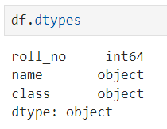

**How to access any column in Dataframe ?**

By using **df['name'] or df.name** here name should be one of the column name in dataframe

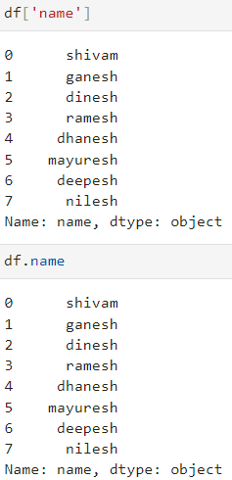

**index:** provides information about the index (row labels) of a DataFrame

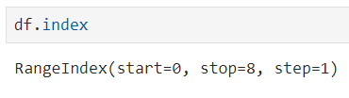

**Importing file as dataframe**

having file data.csv and will import same

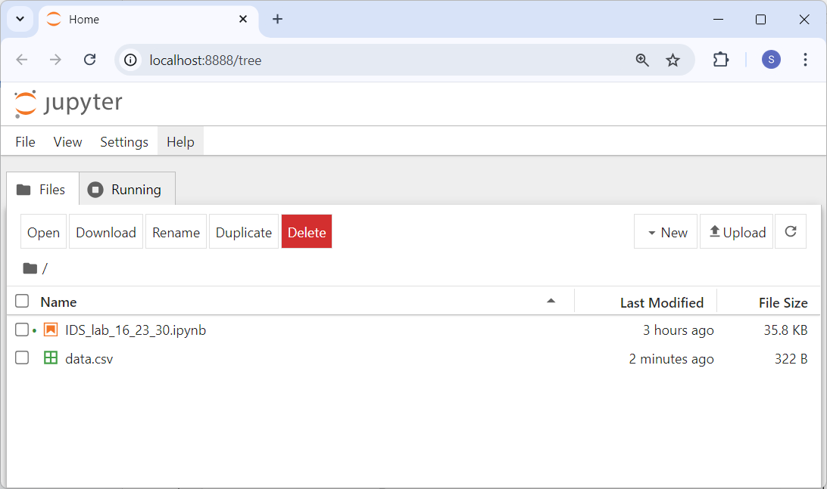

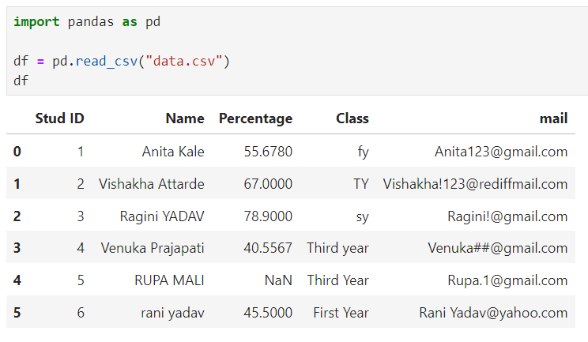

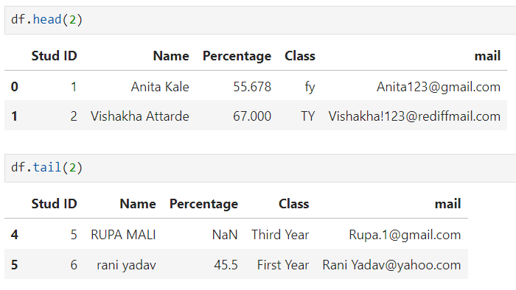

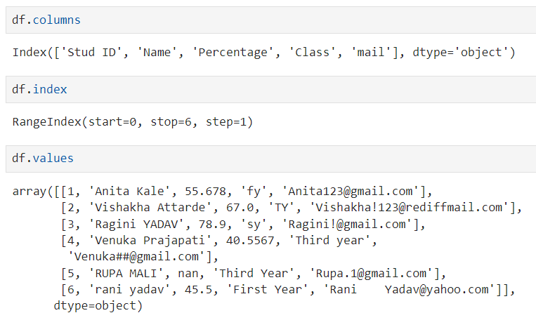

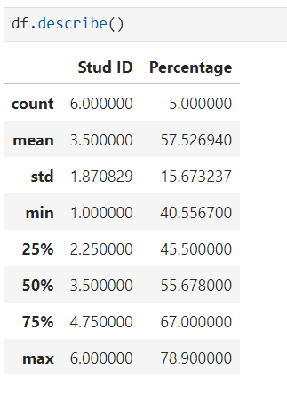

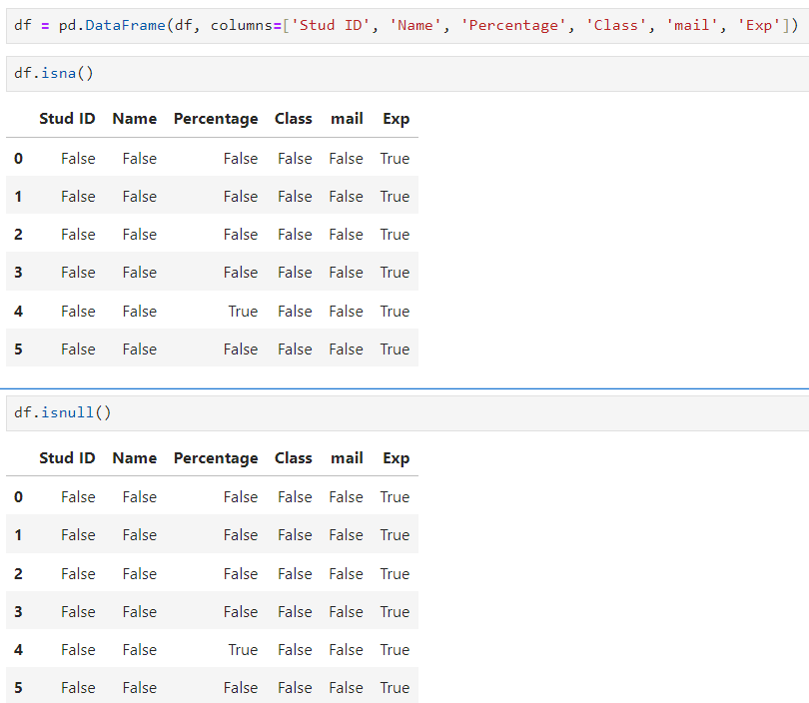

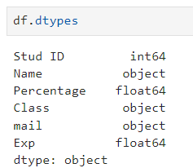

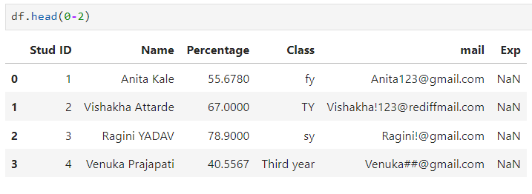

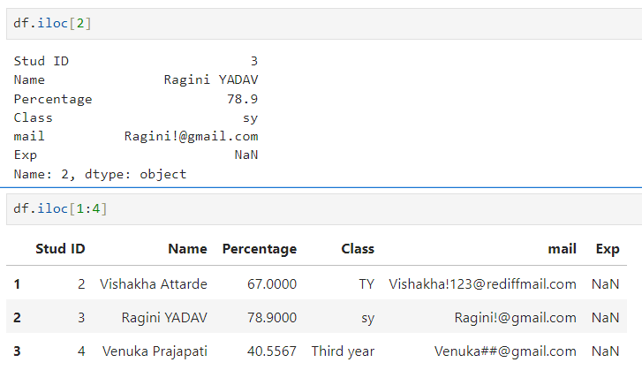

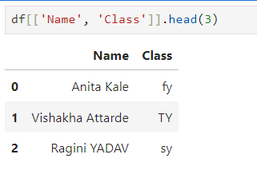

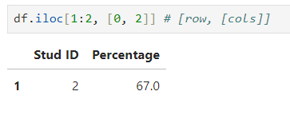

Adding column to dataframe using series

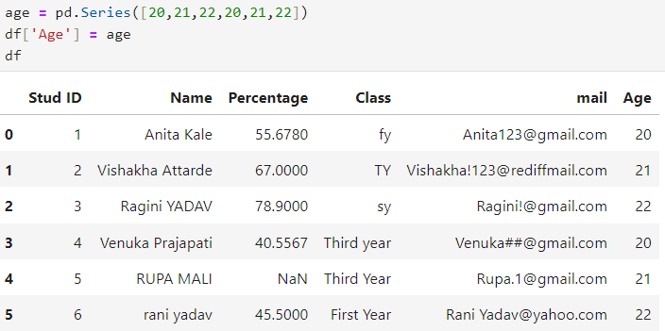

**Q] Create the following dataframe from the given data.**

Dataframe:

c1 c2 c3

row1 10 11 12

row2 13 14 15

row3 14 17 18

Given data:

10,11,12,13,14,15,14,17,18

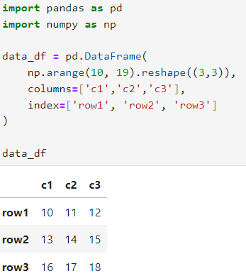

Display the second row of the dataframe.

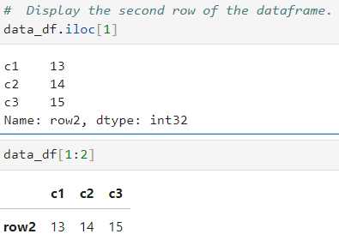

Store the first, second and third row of the dataframe in the variable r1, r2 and r3 and add each individual element of all rows.

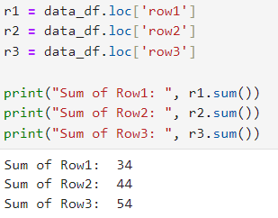

Store the values 1,2,3 in a series s1. Add the series s1 into the above dataframe.

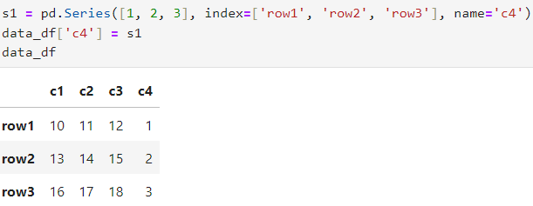

##### 

##### **MATPLOTLIB**

* Matplotlib is a low level graph plotting library in python that serves as a visualization utility.
* Matplotlib is mostly written in python, a few segments are written in C, Objective-C and Javascript for Platform compatibility.
* It provides a variety of tools to generate plots, histograms, bar charts, error charts, scatter plots, and much more.

| import matplotlib.pyplot as plt  age = [1, 2, 3, 4, 5]  height = [1.5, 2, 2.5, 3, 3.5]  plt.figure()  plt.plot(age, height,  marker='o', # Marker for data points  linestyle='-', # Line style  color='purple', # Line color  linewidth=1.5, # Line width  markersize=6, # Marker size  label='Height vs Age') # Label for legend  plt.title('Age vs Height Graph', fontsize=14, fontweight='bold')  plt.xlabel('Age (years)', fontsize=12)  plt.ylabel('Height (meters)', fontsize=12)  plt.legend() # Add a legend  plt.grid(True) # Add a grid  plt.show() # Display the plot |
| --- |

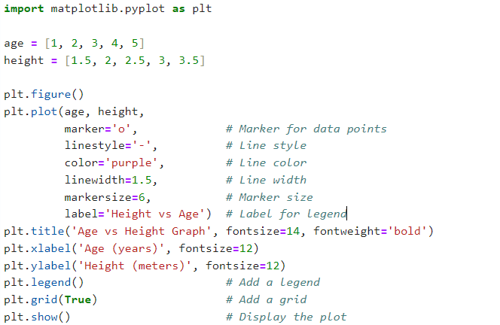

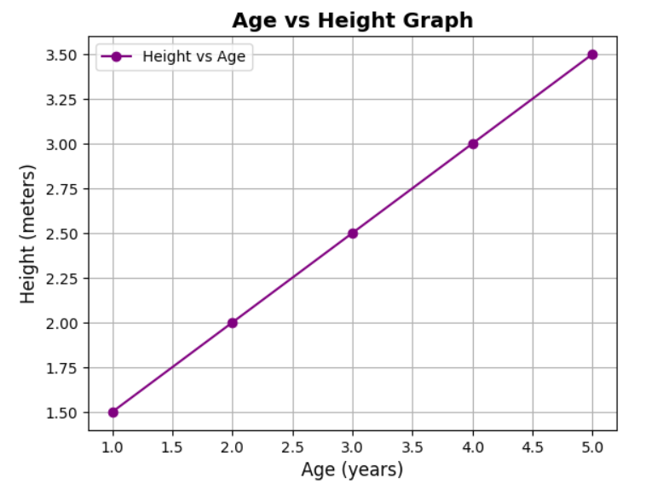

#### 

#### **Practical 2 - Conversion of semi structured and unstructured data to csv**

Aug 6, 2024

**CSV to CSV**

| **c1** | **c2** | **c3** | **c4** |
| --- | --- | --- | --- |
| 1 | Shivam Vishwakarma | 21 | 2000000 |
| 2 | Onkar Ghate | 27 | 3000000 |
| 3 | Akshay Ranpariya | 30 | 1500000 |
| 4 | Neha Dawale | 23 | 2500000 |
| 5 | Hardik Sane | 24 | 3000000 |

Import the data set and required modules that is pandas

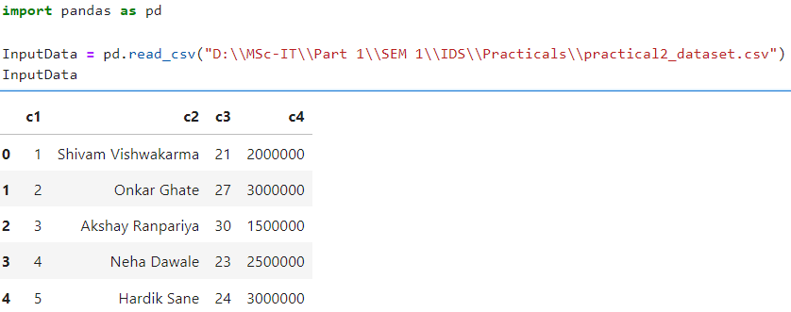

Renaming the columns as per requirements

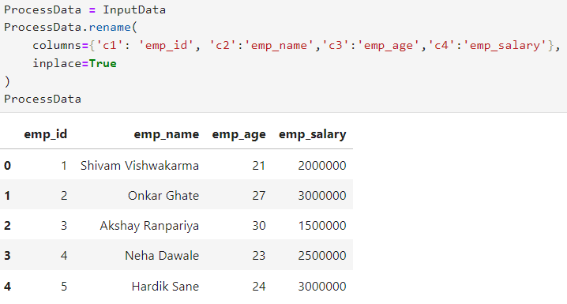

Removing or dropping the unwanted columns

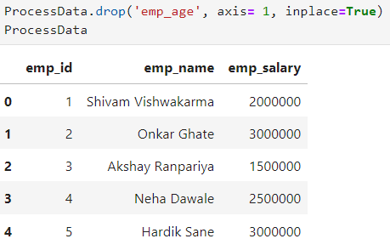

Setting emp_id as index

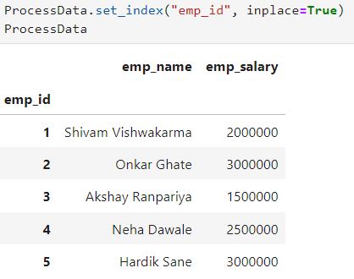

Sorting the employees on the basis of higher salary package

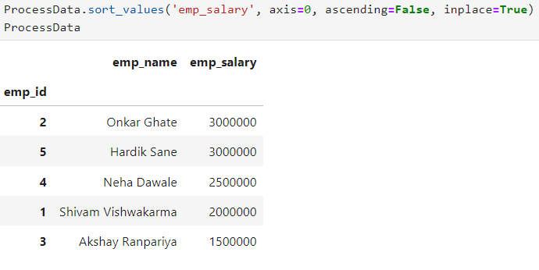

And saving the processed data into csv named as FinalEmp.csv

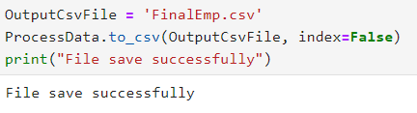

FinalEmp.csv

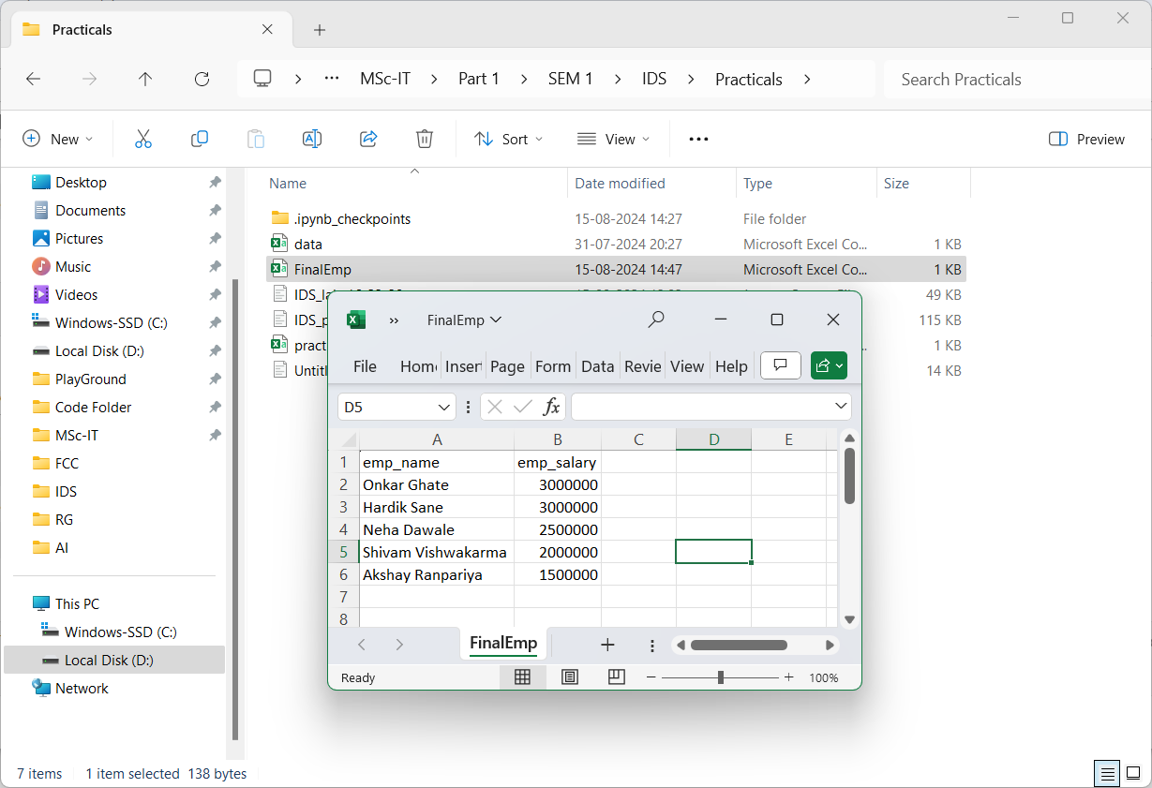

| import pandas as pd  # Import the data set  InputData = pd.read_csv("D:\\MSc-IT\\Part 1\\SEM 1\\IDS\\Practicals\\practical2_dataset.csv")  print("Input dataset : \n", InputData)  # Renaming the columns as per requirements  ProcessData = InputData  ProcessData.rename(  columns={'c1': 'emp_id', 'c2':'emp_name','c3':'emp_age','c4':'emp_salary'},  inplace=True  )  print("\nProcessing Dataset with new column names : \n", ProcessData)  # Removing or dropping the unwanted columns  ProcessData.drop('emp_age', axis= 1, inplace=True)  print("\nProcessing Dataset after removing 'emp_age' column : \n", ProcessData)  # Setting emp_id as index  ProcessData.set_index("emp_id", inplace=True)  print("\nProcessing Dataset with 'emp_id' as Index: \n", ProcessData)  # Sorting the employees on the basis of higher salary package  ProcessData.sort_values('emp_salary', axis=0, ascending=False, inplace=True)  print("\nProcessing Dataset as higher salary sorted: \n", ProcessData)  # saving the processed data into csv named as FinalEmp.csv  OutputCsvFile = 'FinalEmp.csv'  ProcessData.to_csv(OutputCsvFile, index=False)  print("\nFile save successfully") |
| --- |

**XML to CSV**

| <?xml version="1.0" encoding="UTF-8"?>  <root>  <row>  <c1>1</c1>  <c2>Shivam Vishwakarma</c2>  <c3>21</c3>  <c4>2000000</c4>  </row>  <row>  <c1>2</c1>  <c2>Onkar Ghate</c2>  <c3>27</c3>  <c4>3000000</c4>  </row>  <row>  <c1>3</c1>  <c2>Akshay Ranpariya</c2>  <c3>30</c3>  <c4>1500000</c4>  </row>  <row>  <c1>4</c1>  <c2>Neha Dawale</c2>  <c3>23</c3>  <c4>2500000</c4>  </row>  <row>  <c1>5</c1>  <c2>Hardik Sane</c2>  <c3>24</c3>  <c4>3000000</c4>  </row>  </root> |
| --- |

**code**

| import pandas as pd  import xml.etree.ElementTree as ET  def xml2df(xml_data):  root = ET.XML(xml_data)  all_records = []  # Iterate over each child element (record) in the root  for i, child in enumerate(root):  record = {}  # Extract data from each sub-element (fields) of the record  for subchild in child:  record[subchild.tag] = subchild.text  all_records.append(record)    return pd.DataFrame(all_records)  # File paths  sInputFileName = "D:\\MSc-IT\\Part 1\\SEM 1\\IDS\\Practicals\\Practical 2\\practical2_dataset.xml"  sOutputFileName = "D:\\MSc-IT\\Part 1\\SEM 1\\IDS\\Practicals\\Practical 2\\FinalEmp(xml to csv).csv"  # Read XML data from the file  InputData = open(sInputFileName).read()  print(InputData)  # Process XML data  ProcessDataXML = InputData  ProcessData = xml2df(ProcessDataXML)  print(ProcessData)  # Rename columns  ProcessData.rename(  columns={  'c1': 'EmpID',  'c2': 'EmpName',  'c3': 'EmpAge',  'c4': 'AnnualPackage'  },  inplace=True  )  print(ProcessData)  # Set 'EmpID' as the index  ProcessData.set_index('EmpID', inplace=True)  print(ProcessData)  # Sort values by 'AnnualPackage' in descending order  ProcessData.sort_values(  'AnnualPackage',  axis=0,  ascending=False,  inplace=True  )  print(ProcessData)  # Drop the 'EmpAge' column  ProcessData.drop('EmpAge', axis=1, inplace=True)  print(ProcessData)  # Save the final DataFrame to a CSV file  OutputData = ProcessData  OutputData.to_csv(sOutputFileName, index=False)  print("\nFile save successfully") |
| --- |

**Output**

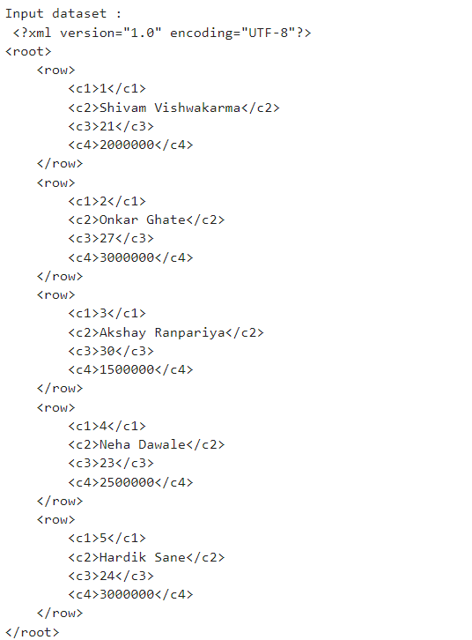

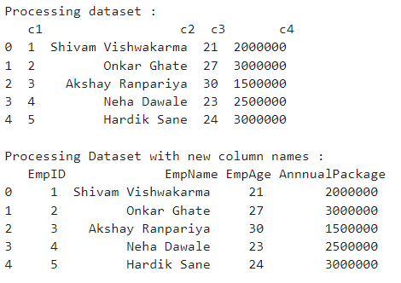

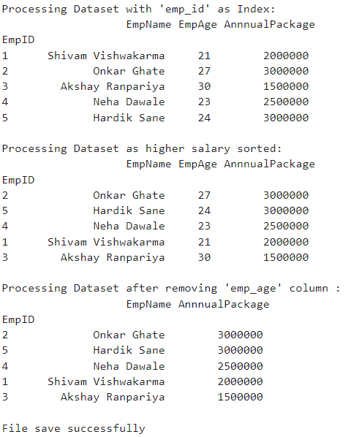

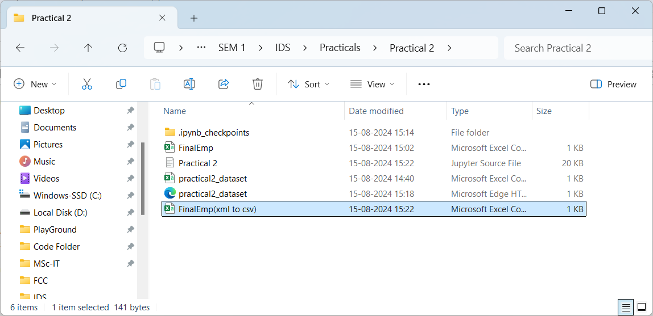

**JSON to CSV**

| [  {  "c1": "1",  "c2": "Shivam Vishwakarma",  "c3": "21",  "c4": "2000000"  },  {  "c1": "2",  "c2": "Onkar Ghate",  "c3": "27",  "c4": "3000000"  },  {  "c1": "3",  "c2": "Akshay Ranpariya",  "c3": "30",  "c4": "1500000"  },  {  "c1": "4",  "c2": "Neha Dawale",  "c3": "23",  "c4": "2500000"  },  {  "c1": "5",  "c2": "Hardik Sane",  "c3": "24",  "c4": "3000000"  }  ] |
| --- |

**code**

| import pandas as pd  # File paths  sInputFileName = "D:\\MSc-IT\\Part 1\\SEM 1\\IDS\\Practicals\\Practical 2\\practical2_dataset.json"  sOutputFileName = "D:\\MSc-IT\\Part 1\\SEM 1\\IDS\\Practicals\\Practical 2\\FinalEmp(json to csv).json"  # Read JSON data from the file  InputData = pd.read_json(sInputFileName, encoding="latin-1")  print('Original Data:')  print(InputData)  print('\n')  # Process Data  ProcessData = InputData  # Rename columns  ProcessData.rename(  columns={  'c1': 'EmpID',  'c2': 'EmpName',  'c3': 'EmpAge',  'c4': 'AnnnualPackage'  },  inplace=True  )  print(ProcessData)  # Set 'EmpID' as the index  ProcessData.set_index('EmpID', inplace=True)  print(ProcessData)  # Sort values by 'AnnnualPackage' in descending order  ProcessData.sort_values(  'AnnnualPackage',  axis=0,  ascending=False,  inplace=True  )  print(ProcessData)  # Drop the 'EmpAge' column  ProcessData.drop('EmpAge', axis=1, inplace=True)  print(ProcessData)  # Save the final DataFrame to a CSV file  OutputData = ProcessData  OutputData.to_csv(sOutputFileName, index=False)  print("\nFile save successfully") |
| --- |

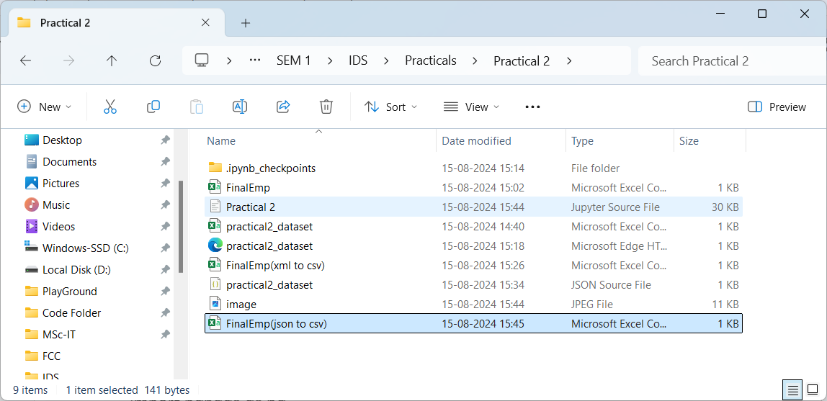

**Images to csv**

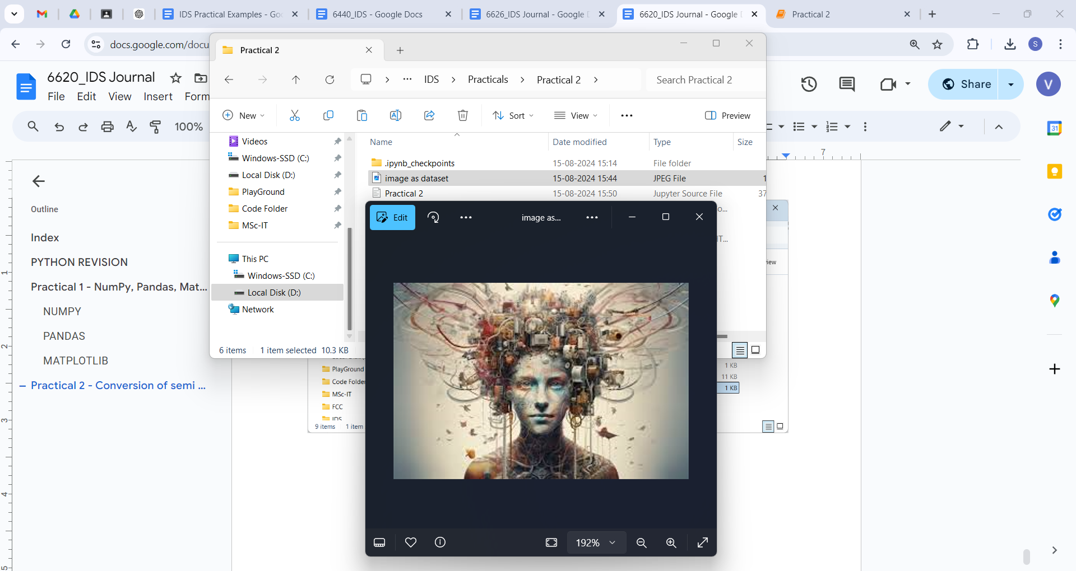

**code**

| import imageio.v3 as iio # pip install imageio  import pandas as pd  import matplotlib.pyplot as plt  import numpy as np  # File paths  sInputFileName = "D:\\MSc-IT\\Part 1\\SEM 1\\IDS\\Practicals\\Practical 2\\image as dataset.jpeg"  sOutputFileName = "D:\\MSc-IT\\Part 1\\SEM 1\\IDS\\Practicals\\Practical 2\\image dataset(image to csv).csv"  # Read the image  InputData = iio.imread(sInputFileName)  # Print the dimensions of the image  print('X: ', InputData.shape[0])  print('Y: ', InputData.shape[1])  # Check if the image has 2 dimensions (grayscale) or 3 dimensions (RGB)  if len(InputData.shape) == 3:  # RGB Image  num_channels = InputData.shape[2]  else:  # Grayscale Image (treat it as having 1 channel)  num_channels = 1  InputData = np.expand_dims(InputData, axis=-1) # Add a channel dimension  # Flatten the image data and reshape it into a DataFrame  ProcessRawData = InputData.flatten()  y = num_channels + 2  x = int(ProcessRawData.shape[0] / y)  ProcessData = pd.DataFrame(np.reshape(ProcessRawData, (x, y)))  # Adjust column names based on the number of channels  if num_channels == 3:  sColumns = ['XAxis', 'YAxis', 'Red', 'Green', 'Blue']  elif num_channels == 4:  sColumns = ['XAxis', 'YAxis', 'Red', 'Green', 'Blue', 'Alpha']  else:  sColumns = ['XAxis', 'YAxis', 'Gray']  ProcessData.columns = sColumns  ProcessData.index.names = ['ID']  # Print the dimensions of the DataFrame  print('Rows: ', ProcessData.shape[0])  print('Columns: ', ProcessData.shape[1])  print('\n')  # Display the image  print('Process Data Values:')  plt.imshow(InputData.squeeze())  plt.show()  print('\n')  # Save the DataFrame to a CSV file  OutputData = ProcessData  OutputData.to_csv(sOutputFileName, index=False)  print("\nFile save successfully") |
| --- |

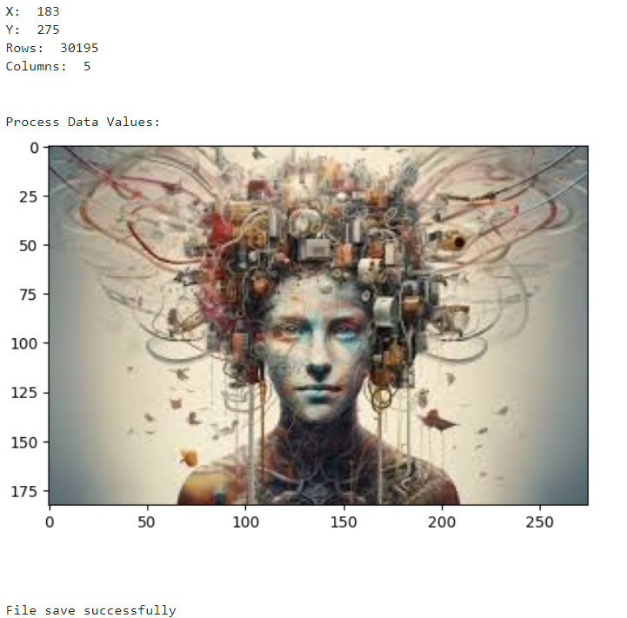

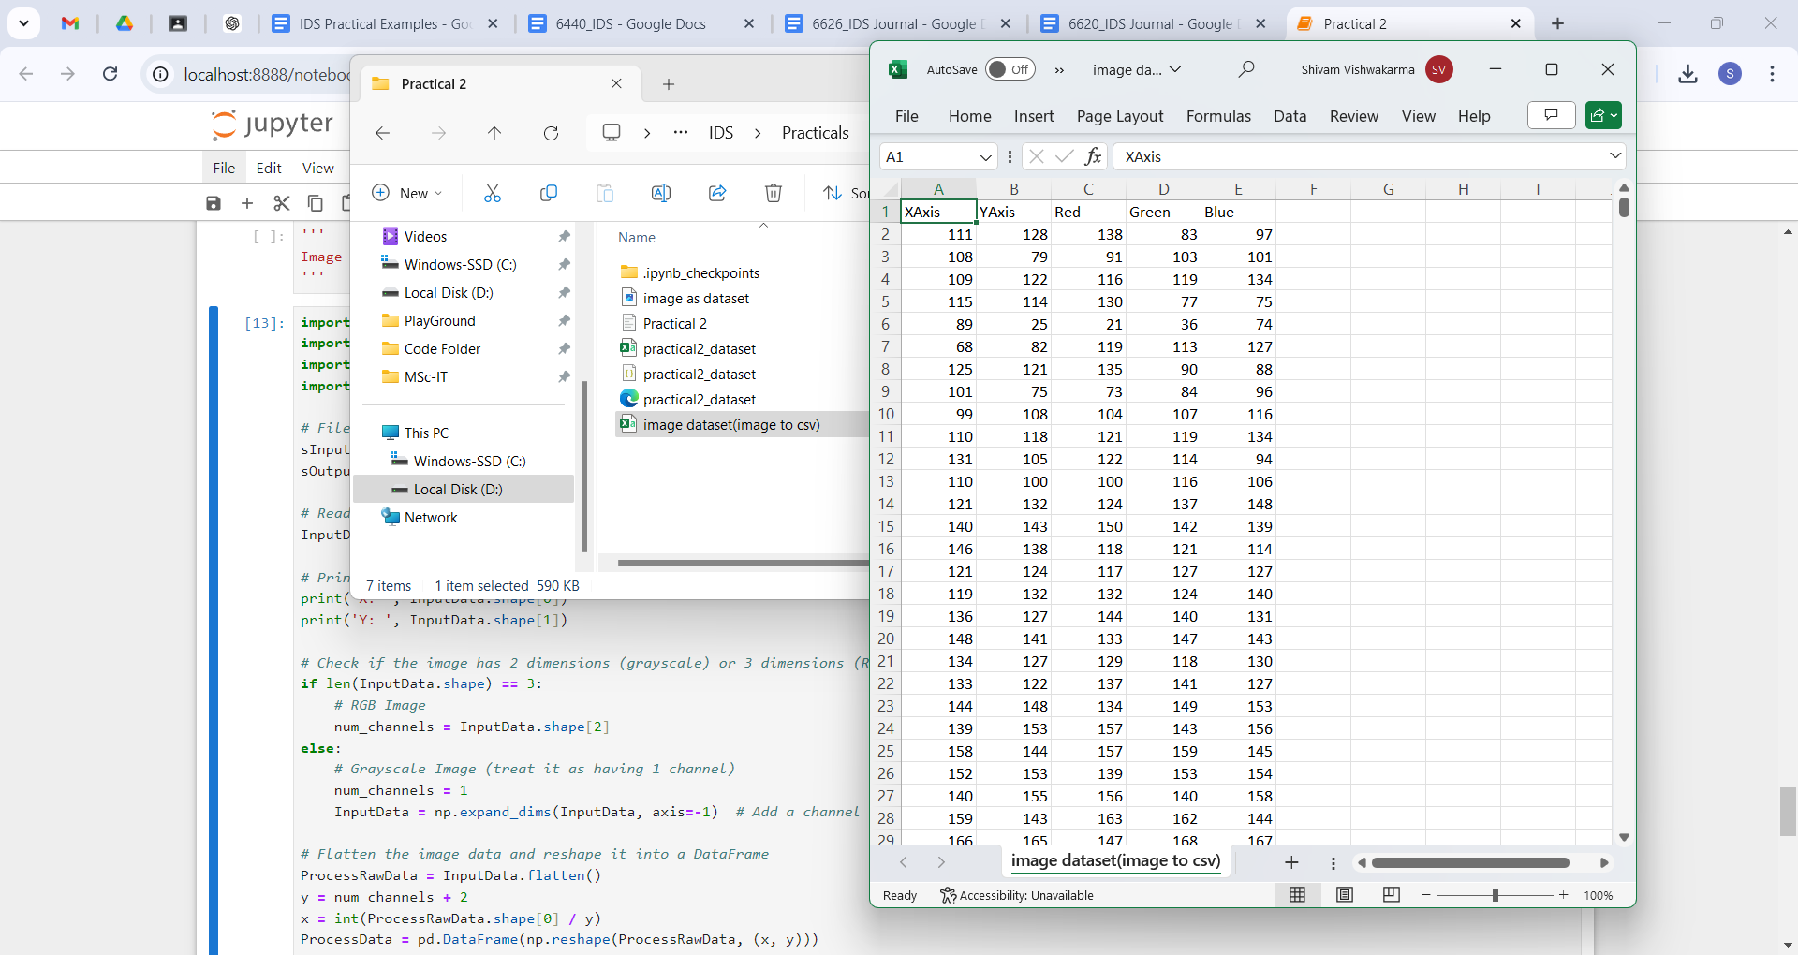

**Video to Frames**

**code**

| import os  import shutil  import cv2 # pip install opencv-python  # File paths and directory  sInputFileName = "D:\\MSc-IT\\Part 1\\SEM 1\\IDS\\Practicals\\Practical 2\\video as dataset.mp4"  sDataBaseDir = "D:\\MSc-IT\\Part 1\\SEM 1\\IDS\\Practicals\\Practical 2\\Frames"  # Check if the input video file exists  if not os.path.exists(sInputFileName):  print(f"Error: The file {sInputFileName} does not exist.")  raise FileNotFoundError(f"{sInputFileName} not found.")  # Remove the directory if it exists and recreate it  if os.path.exists(sDataBaseDir):  shutil.rmtree(sDataBaseDir)  os.makedirs(sDataBaseDir)  print('\nStart Movie to Frames\n')  # Open the video file  vidcap = cv2.VideoCapture(sInputFileName)  success, image = vidcap.read()  if not success:  print("Error: Failed to read the video file.")  else:  count = 0  while success:  # Create frame file path  sFrame = os.path.join(sDataBaseDir, f'ocean-frame-{count:04d}.jpg')    # Save the frame as an image file  print('Extracted:', sFrame)  cv2.imwrite(sFrame, image)    # Check if the frame was written successfully  if os.path.getsize(sFrame) == 0:  count -= 1  os.remove(sFrame)  print('Removed:', sFrame)    # Read the next frame  success, image = vidcap.read()  count += 1    print('Generated:', count, 'Frames')  print('\nMovie to Frames HORUS - Done') |
| --- |

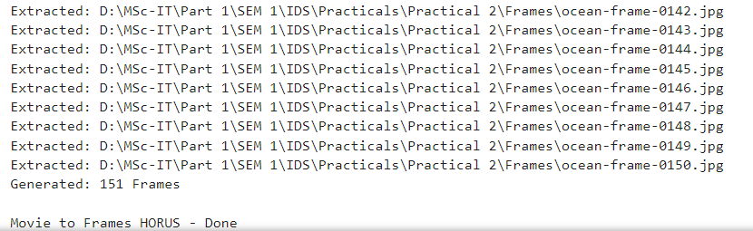

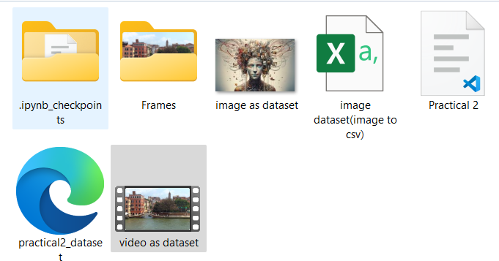

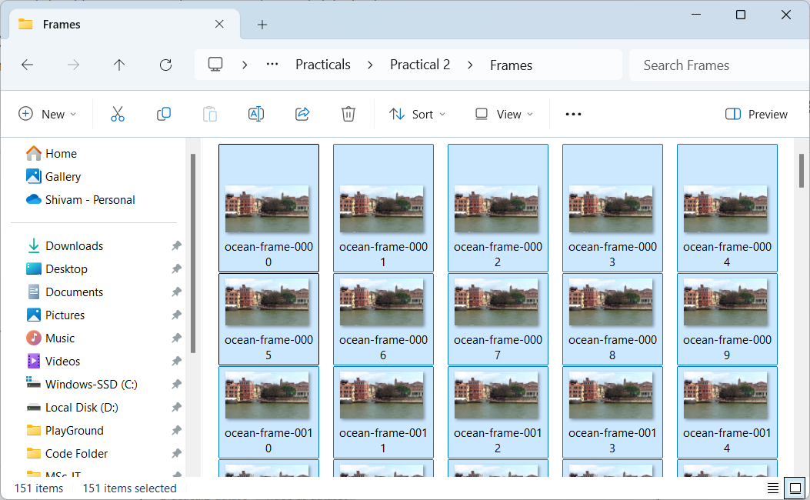

**Frame to CSV**

**code**

| import imageio.v2 as imageio  import pandas as pd  import matplotlib.pyplot as plt  import numpy as np  import os  # Directory containing the frames  sDataBaseDir = "D:\\MSc-IT\\Part 1\\SEM 1\\IDS\\Practicals\\Practical 2\\Frames"  # Initialize counters and list for processing  f = 0  ProcessDataList = [] # List to hold DataFrames before concatenation  # Process each image file in the directory  for file in os.listdir(sDataBaseDir):  if file.endswith(".jpg"):  f += 1  sInputFileName = os.path.join(sDataBaseDir, file)  print('Processing: ', sInputFileName)    # Read the image  InputData = imageio.imread(sInputFileName)    # Print image dimensions  print('Input Data Values:')  print('X: ', InputData.shape[0])  print('Y: ', InputData.shape[1])  print('RGBA: ', InputData.shape[2])    # Processing Rules ===========================================  ProcessRawData = InputData.flatten()  y = InputData.shape[2] + 2  x = int(ProcessRawData.shape[0] / y)  ProcessFrameData = pd.DataFrame(np.reshape(ProcessRawData, (x, y)))  ProcessFrameData['Frame'] = file    # Print column count and display image  print('Number of columns in ProcessFrameData:', len(ProcessFrameData.columns))  print('\n')  print('Process Data Values:')  print('\n')  plt.imshow(InputData)  plt.show()    # Append DataFrame to the list  ProcessDataList.append(ProcessFrameData)  # After processing all frames  if f > 0:  # Check column count for the first DataFrame  print('Columns in the first DataFrame:', ProcessDataList[0].shape[1])    # Concatenate all DataFrames  ProcessData = pd.concat(ProcessDataList, ignore_index=True)    # Print column count after concatenation  print('Columns in concatenated DataFrame:', ProcessData.shape[1])    # Define column names  sColumns = ['XAxis', 'YAxis', 'Red', 'Green', 'Blue', 'Alpha', 'FrameName']    # Check if column names match the number of columns in the DataFrame  if ProcessData.shape[1] == len(sColumns):  ProcessData.columns = sColumns  else:  print(f'Column count mismatch: DataFrame has {ProcessData.shape[1]} columns but {len(sColumns)} names provided.')  # Set index name and print DataFrame dimensions  print('\n')  ProcessData.index.names = ['ID']  print('Rows: ', ProcessData.shape[0])  print('Columns: ', ProcessData.shape[1])  print('\n')    # Output DataFrame to CSV  OutputData = ProcessData  sOutputFileName = "D:\\MSc-IT\\Part 1\\SEM 1\\IDS\\Practicals\\Practical 2\\video dataset(frames to csv).csv"  OutputData.to_csv(sOutputFileName, index=False)  print('\n')  print('Processed: ', f, ' frames') |
| --- |

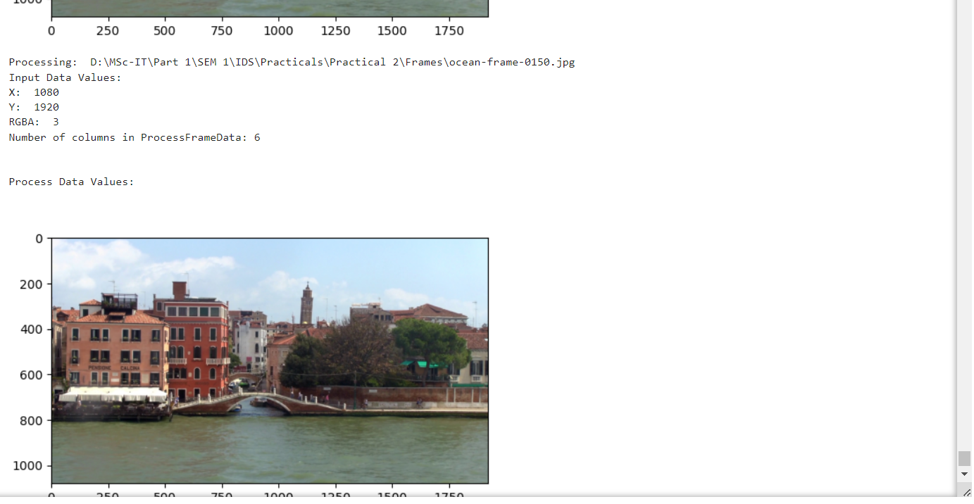

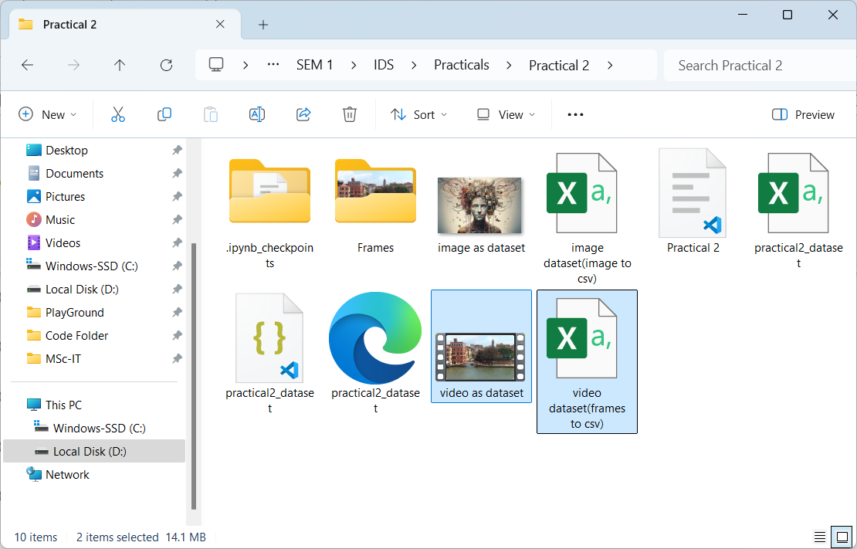

**SQL to CSV**

| import sqlite3  import os  # Define the file path  db_file = "D:\\MSc-IT\\Part 1\\SEM 1\\IDS\\Practicals\\Practical 2\\practical2_database.db"  # Remove the file if it already exists  if os.path.exists(db_file):  os.remove(db_file)  # Connect to SQLite database (it will be created)  conn = sqlite3.connect(db_file)  cursor = conn.cursor()  # Create the employees table  cursor.execute('''  CREATE TABLE employees (  c1 INTEGER PRIMARY KEY, -- EmpID  c2 TEXT NOT NULL, -- EmpName  c3 INTEGER NOT NULL, -- EmpAge  c4 REAL NOT NULL -- AnnualPackage  );  ''')  # Insert sample data into the 'employees' table  employee_data = [  (1, 'Shivam Vishwakarma', 21, 2000000),  (2, 'Onkar Ghate', 27, 3000000),  (3, 'Akshay Ranpariya', 30, 1500000),  (4, 'Neha Dawale', 43, 2500000),  (5, 'Hardik Sane', 24, 3000000)  ]  cursor.executemany('INSERT INTO employees (c1, c2, c3, c4) VALUES (?, ?, ?, ?);', employee_data)  # Commit changes and close the connection  conn.commit()  conn.close()  print("Database created successfully with employee data!") |
| --- |



| import pandas as pd  import sqlite3  # File paths  sInputFileName = "D:\\MSc-IT\\Part 1\\SEM 1\\IDS\\Practicals\\Practical 2\\practical2_database.db" # SQLite DB file  sOutputFileName = "D:\\MSc-IT\\Part 1\\SEM 1\\IDS\\Practicals\\Practical 2\\FinalEmp.csv" # Output CSV file  # Connect to the SQLite database  conn = sqlite3.connect(sInputFileName)  # Read data from the SQL table (replace 'your_table_name' with the actual table name)  InputData = pd.read_sql_query("SELECT * FROM employees", conn)  print('Original Data:')  print(InputData)  print('\n')  # Process Data  ProcessData = InputData  # Rename columns  ProcessData.rename(  columns={  'c1': 'EmpID',  'c2': 'EmpName',  'c3': 'EmpAge',  'c4': 'AnnualPackage' # Fixed typo from 'AnnnualPackage' to 'AnnualPackage'  },  inplace=True  )  # Set 'EmpID' as the index  ProcessData.set_index('EmpID', inplace=True)  # Sort values by 'AnnualPackage' in descending order  ProcessData.sort_values(  'AnnualPackage',  axis=0,  ascending=False,  inplace=True  )  # Drop the 'EmpAge' column  ProcessData.drop('EmpAge', axis=1, inplace=True)  # Save the final DataFrame to a CSV file  OutputData = ProcessData  OutputData.to_csv(sOutputFileName, index=True) # Set index=True to include 'EmpID'  print("\nFile saved successfully")  # Close the database connection  conn.close() |
| --- |

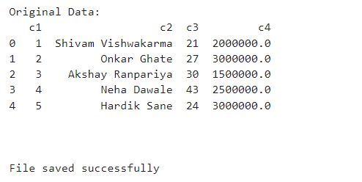

#### **Practical 3 - Data Processing for various types of data**

Aug 10, 2024

Iris.csv → <https://gist.github.com/netj/8836201>

**code**

| import pandas as pd  import numpy as np  # Load data from a CSV file  data = pd.read_csv("D:\\6626_Ariba\\iris.csv")  print("Original Data:")  df = pd.DataFrame(data)  print(df)  print("\n")  # Information about the DataFrame  print("Information:")  print(df.info())  print("\n")  # Description of the DataFrame  print("Description:")  print(df.describe())  print("\n")  # Data types of each column  print("Data types of each column:")  print(df.dtypes)  print("\n")  # Total number of non-null values in each column  print("Total number of records:")  print(df.count())  print("\n")  # Total number of rows and columns  print("Total number of rows and columns:")  print(df.shape)  print("\n")  # Column names  print("Column names:")  print(df.columns)  print("\n")  # Column values as a NumPy array  print("Column values:")  print(df.values)  print("\n")  # Dimension of the DataFrame  print("Dimension of dataframe:")  print(df.ndim)  print("\n")  # Size of the DataFrame (total number of elements)  print("Size of dataframe:")  print(df.size)  print("\n")  # Checking for null/missing/blank values  print("Checking null/missing/blank values:")  print(df.isnull())  print("\n")  # Checking for non-null values  print("Checking non-null values:")  print(df.notnull())  print("\n")  # Checking for null/missing/blank values and filling with a given value  print("Checking null/missing/blank values and fill with given values:")  print(df.fillna(1)) # 1 can be replaced by any other value  print("\n")  # Replacing NaN values with a given value  print("Replace the NaN values with given values:")  print(df.replace(to_replace=np.nan, value=0)) # 0 can be replaced by any other value |
| --- |

**output**

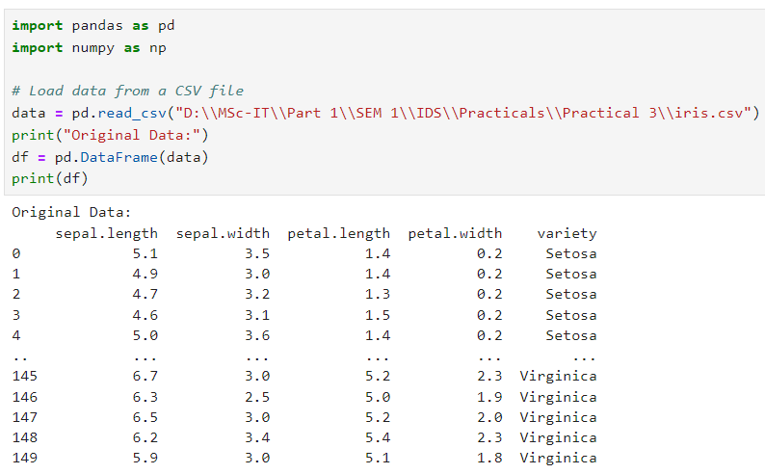

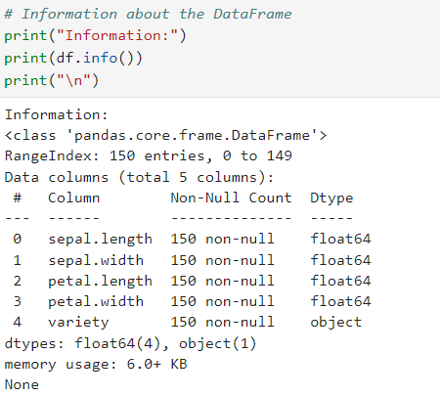

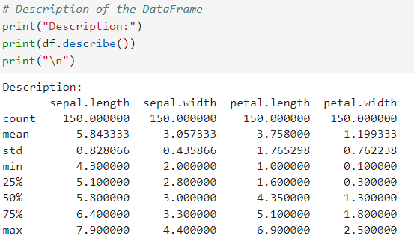

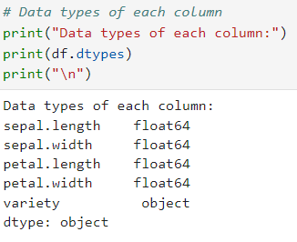

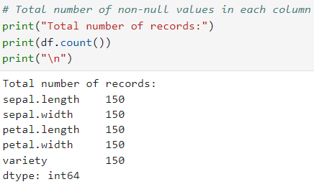

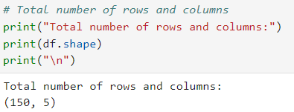

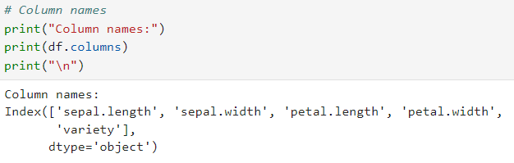

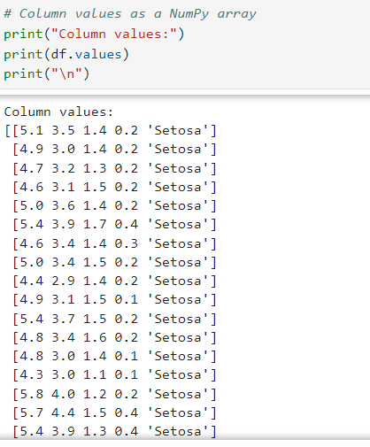

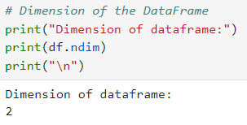

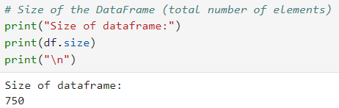

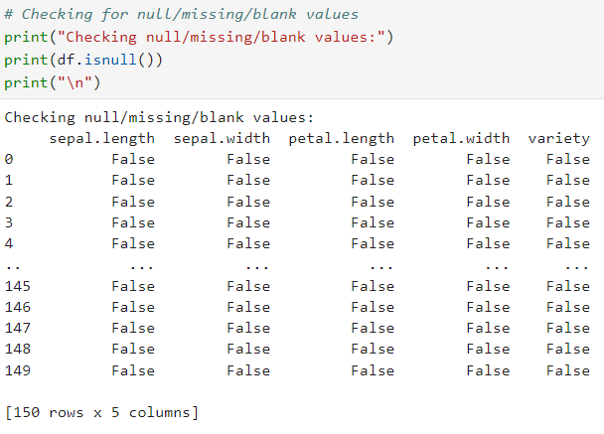

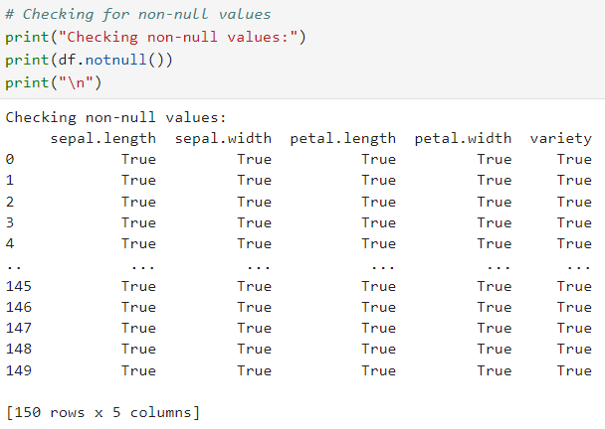

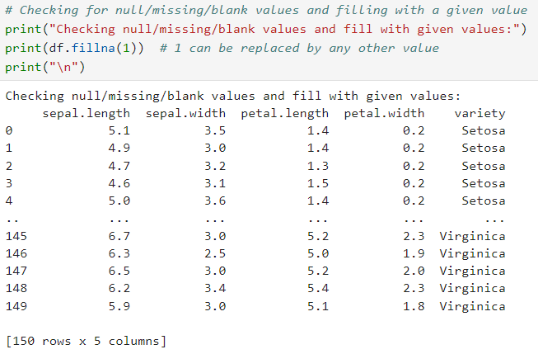

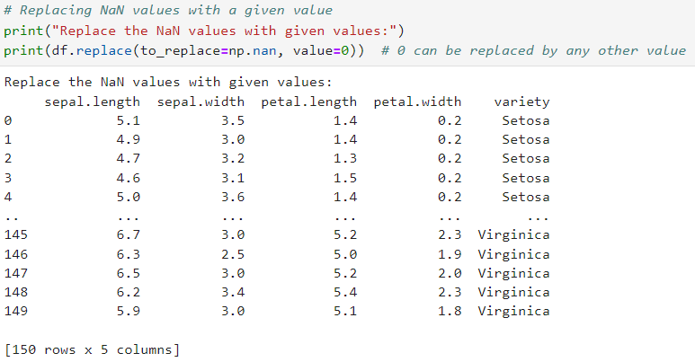

**Q] Create the data frame for the given data and process the data frame data for the null or missing values.**

Columns: 'EmpName' ,DOJ,Exp,Pkg,Manager,Team

row_1:’Amit’, ‘01-02-2000’, ‘10 years’, 4000000,’Sapkal’, ‘Marketing’

row_2:’Vishakha’, ‘03-05-2010’, ‘5 years’, 3000000,’Sanap’, ‘Digital’

row_3:’Aniket’, ‘01-02-2006’, NaN, 4500000,’Sapkal’, ‘Legal’

row_4:Nan, ‘10-08-2004’, ‘15years’, Nan,’Pankaj’, ‘Marketing’

| data = { 'EmpName' : ['Rohan','ShreeLaxmee','Priyanka','Vijay', 'Biswajeet'],  'DOJ' : ['01-02-2000', '03-05-2010', '01-02-2006', '10-08-2004', 'None'],  'Exp' : ['10 years', '5 years', 'NaN', '15 years', '30 years'],  'Pkg' : ['NaN',3000000,4500000,650000,4000000],  'Manager' : ['Sakpal', 'Sanap', 'Sakpal', 'Pankaj', 'Sanika'],  'Team' : ['Marketing', 'Digital', 'Legal', 'Marketing', 'Legal'],  }  df = pd.DataFrame(data)  df |
| --- |

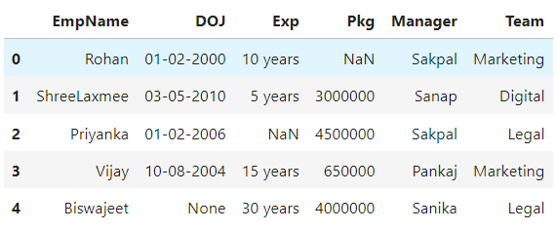

| # Replace 'NaN' with np.nan  df.replace('NaN', np.nan, inplace=True)  # Explicitly infer data types to retain old behavior  df = df.infer_objects(copy=False)  df |
| --- |

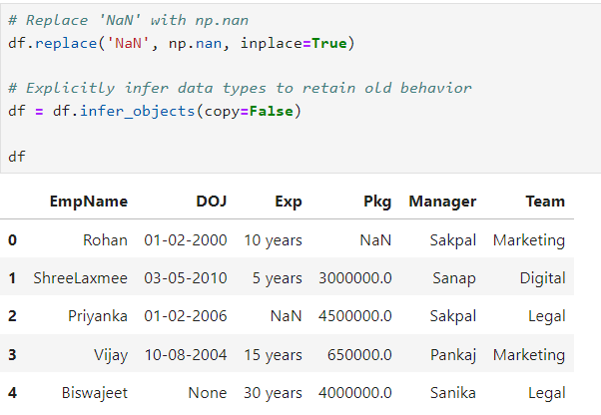

1. Remove the rows with missing names

| df = df.dropna(subset=["EmpName"])  df |
| --- |

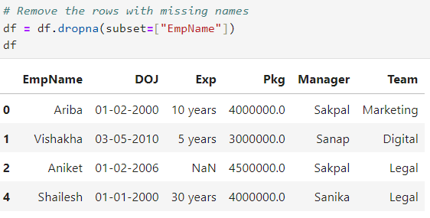

1. Replace the missing date with the string ‘01-01-2000’

| df['DOJ'] = df['DOJ'].replace('None', '01-01-2000')  df |
| --- |

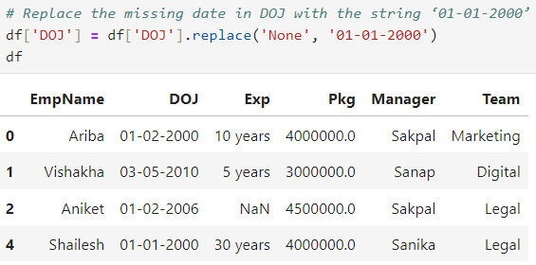

1. Replace the missing experience with the value ‘0 Years’

| df['Exp'] = df['Exp'].replace(np.nan, '0 years')  df |
| --- |

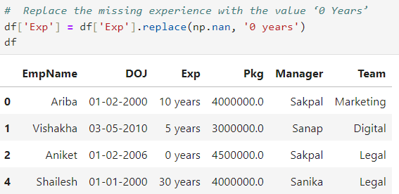

1. Replace the missing package with the values 500000

| df['Pkg'] = df['Pkg'].replace(np.nan, 500000)  df |
| --- |

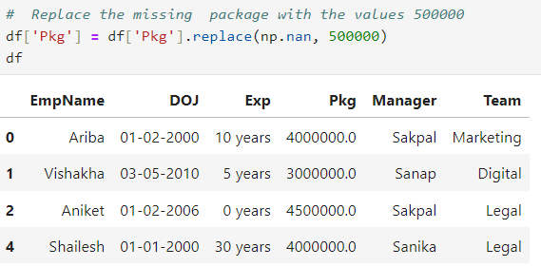

**Q] Create the data frame for the given data and process the data frame data for the null or missing values.**

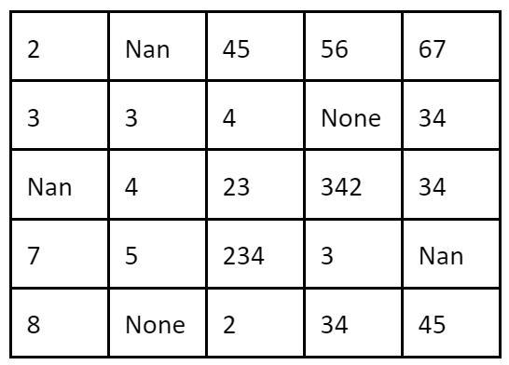

**Columns: Col1, Col2, Col3, Col4 and Col5**

| data = {  'Col1' : [2, 3, np.nan, 7, 8],  'Col2' : [np.nan, 3, 4, 5, 'None'],  'Col3' : [45, 4, 23, 234, 2],  'Col4' : [56, 'None', 342, 3, 34],  'Col5' : [67, 34, 34, np.nan, 45],  }  df= pd.DataFrame(data)  df |
| --- |

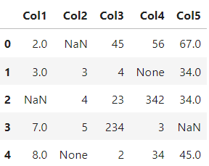

**Replace Col1 values with 0**

| df['Col1'].replace(np.nan, 0, inplace = True)  df |
| --- |

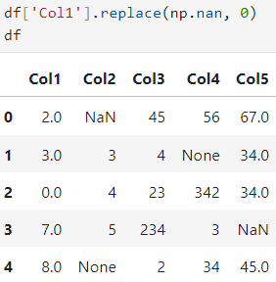

**Replace Col2 values with negative value**

| df.replace({'Col2':'None'}, np.nan, inplace=True)  df['Col2'] = df['Col2'].fillna(-1)  df |
| --- |

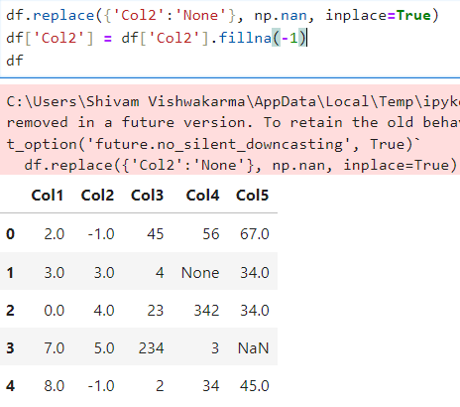

**Replace Col3 values with default value -2**

| df['Col3'] = -2  df |
| --- |

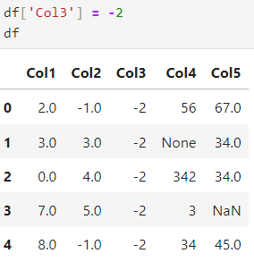

**Replace Col4 values with first value in the column**

| df.replace({'Col4':'None'}, np.nan, inplace=True)  df['Col4'].replace(np.nan, df['Col4'][0], inplace=True)  df |
| --- |

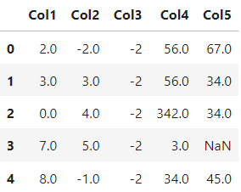

**Replace Col5 values with average of the nonzero values**

| df['Col5'].replace(np.nan, df['Col5'].mean(), inplace=True)  df |
| --- |

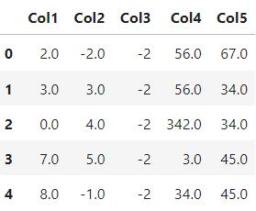

**Rename all columns with some other name.**

| df.rename(columns={  "Col1" : "Col_1",  "Col2" : "Col_2",  "Col3" : "Col_3",  "Col4" : "Col_4",  "Col5" : "Col_5"},  inplace = True  )  df |
| --- |

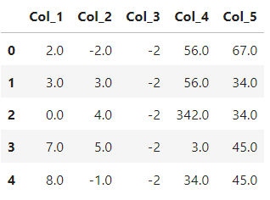

#### 

#### **Practical 4 - Basic Utility design, Data auditing and Exploratory Data Analysis**

Aug 13, 2024

| StudID | Name | Class | Elective | Msg | Test Score | Date of Birth |
| --- | --- | --- | --- | --- | --- | --- |
| Student1 | Ariba | Fy | SBCM | hello | 20 | 06-09-2003 |
| Student2 | Vilas | fy | sbcm | My  Computer | 8 | 02-02-2024 |
| Student3 | Shivam | FY | AI | Hello Guy\s | 5 | 04-03-2006 |
| Student4 | Pranay | fY | AI | Good morning | 11 | 03/31/2003 |
| Student5 | AnIL | Fy | SBCM | hello | 18 | 01-01-2001 |
| Student6 | ViKas | fy | sbcm | My  Computer | 9 | 02-02-2024 |
| Student7 | Vinit | FY | AI | Hello Guy\s | 50 | 04-03-2006 |
| Student8 | Pranali | fY | AI | Good morning | 10 | 03/31/2003 |

**code**

| import pandas as pd  data = {  'StudID': ['Student1', 'Student2', 'Student3', 'Student4', 'Student5', 'Student6', 'Student7', 'Student8'],  'Name': [' Ariba ', 'Vilas', 'Shivam ', ' Pranay ', ' AnIL ', 'ViKas', 'Vinit ', ' Pranali '],  'Class': ['Fy', 'fy', 'FY', 'fY', 'Fy', 'fy', 'FY', 'fY'],  'Elective': ['SBCM', ' sbcm', 'AI', 'AI ', 'SBCM', ' sbcm', 'AI', 'AI '],  'Msg': ['he\x00llo', 'My\nComputer', 'Hello Guy\\s', 'Good morning', 'he\x00llo', 'My\nComputer', 'Hello Guy\\s', 'Good morning'],  'Test Score': [20, 8, 5, 11, 18, 9, 50, 10],  'Date of Birth': ['06-09-2003', '02/02/24', '04-03-2006', '03/31/2003', '01-01-2001', '02/02/24', '04-03-2006', '03/31/2003']  }  df = pd.DataFrame(data)  print("Original Data : ")  df |
| --- |

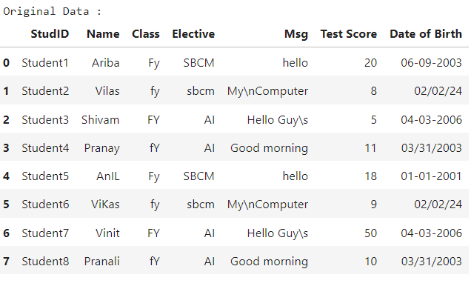

**Basic Utility Design**

1. **Fixer Utility**

**Q] Remove leading and trailing spaces from the data of all columns.**

| df = df.apply(lambda x: x.str.strip() if x.dtype == "object" else x)  print("After removing leading and trailing spaces from dataframe :")  df |
| --- |

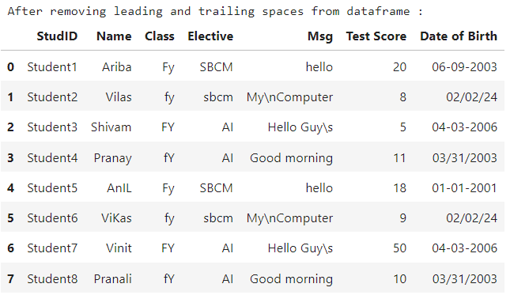

**Q] Remove non-printable characters from the ‘Msg’ Column values.**

| import re  df['Msg'] = df['Msg'].apply(lambda x: re.sub(r'[^\x20-\x7E]', '', x).replace('\\', ''))  print("After removing non-printable characters in Msg column : ")  print(df['Msg']) |
| --- |

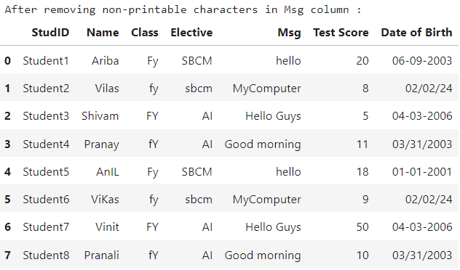

**Q] Reformat the ‘Date of Birth’ column with the format ‘DD-MM-YYYY’**

| from datetime import datetime  def parse_dates(date):  for fmt in ('%d-%m-%Y', '%d/%m/%y', '%m/%d/%Y', '%m/%d/%y'):  try:  return datetime.strptime(date, fmt).strftime('%d-%m-%Y')  except ValueError:  continue  return pd.NaT # If none of the formats work, return NaT  df['Date of Birth'] = df['Date of Birth'].apply(parse_dates)  print("Data after reformatting 'Date of Birth' column:")  df |
| --- |

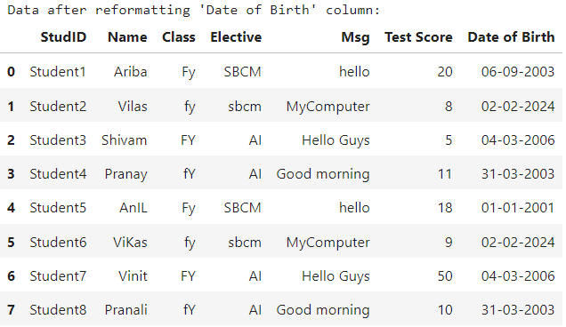

1. **Data Binning or Bucketing**

**Q] Classify the given data based on the students test score into three bins named ‘poor’, ‘average’ and ‘best’.**

| bins = [0, 10, 15, 20]  labels = ['poor', 'average', 'best']  df['Score Category'] = pd.cut(df['Test Score'], bins=bins, labels=labels, include_lowest=True)  print("Bins:")  print(df[['StudID', 'Test Score', 'Score Category']]) |
| --- |

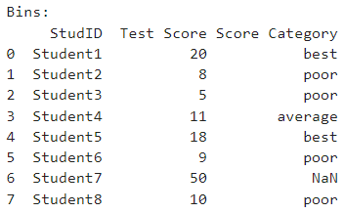

1. **Averaging the Data**

**Q] Get the average test score of the class ‘fy’**

| average_score_fy = df[df['Class'].str.lower() == 'fy']['Test Score'].mean()  print(f"Average Test Score for class 'fy': {average_score_fy}") |
| --- |

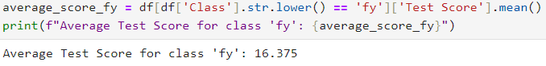

1. **Outlier Detection**

**Q] Check and display the test score Outliers.**

| Q1 = df['Test Score'].quantile(0.25)  Q3 = df['Test Score'].quantile(0.75)  IQR = Q3 - Q1  lower_bound = Q1 - 1.5 * IQR  upper_bound = Q3 + 1.5 * IQR  outliers = df[(df['Test Score'] < lower_bound) | (df['Test Score'] > upper_bound)]  print("Outliers :")  print(outliers[['StudID', 'Test Score']]) |
| --- |

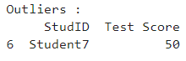

1. **Logging**

**Q] Check the result with the value 1, -1 etc.**

| import logging  logging.basicConfig(level=logging.DEBUG, format='%(asctime)s %(levelname)s - %(message)s')  def perform_operation(value):  if value < 0:  raise ValueError("Invalid value: Value cannot be negative.")  else:  logging.info("Operation performed successfully.")  try:  input_value = int(input("Enter a value: "))  perform_operation(input_value)  except ValueError as ve:  logging.exception("Exception occurred: %s", str(ve)) |
| --- |





1. **Data auditing**

**Q] Check the student date of birth is in the range of 01-01-2000 to 01-01-2025.**

| start = pd.to_datetime('01-01-2000')  end = pd.to_datetime('01-01-2025')  df['Date of Birth'] = pd.to_datetime(df['Date of Birth'], errors='coerce')  dob = df[(df['Date of Birth'] >= start) & (df['Date of Birth'] <= end)]  print(dob[['Name', 'Date of Birth']]) |
| --- |

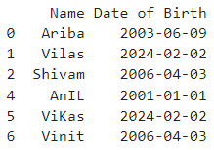

**Q] Check for invalid or wrong test score values. The test score range should be from 0 to 20 only.**

| d = df['Test Score'].values  v = d[(d<0) | (d>20)]  print("Invalid test score :",v) |
| --- |

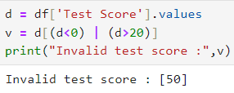

**Q] The student's name should have only alphabetic characters.**

| import re  s = df['Name']  def removePunc(z):  return re.sub('[ 1-9!#.]', '' , z)  result = []  for x in map(removePunc, s):  result.append(x)  print(result) |
| --- |



**Exploratory data analysis**

**Q] Describe students' data and check for average test scores.**

| print("Description of data :")  df.describe() |
| --- |

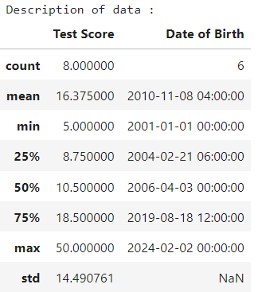

| print("Average of Test Score column is :",df['Test Score'].mean()) |
| --- |

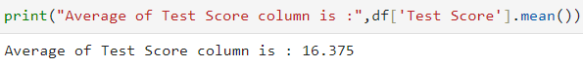

**Q] Check for the data value distribution of the test score column by plotting boxplot.**

| import matplotlib.pyplot as plt  import seaborn as sns # pip install seaborn  plt.figure(figsize=(8, 6))  sns.boxplot(x=df['Test Score'])  plt.title('Boxplot of Test Scores')  plt.show() |
| --- |

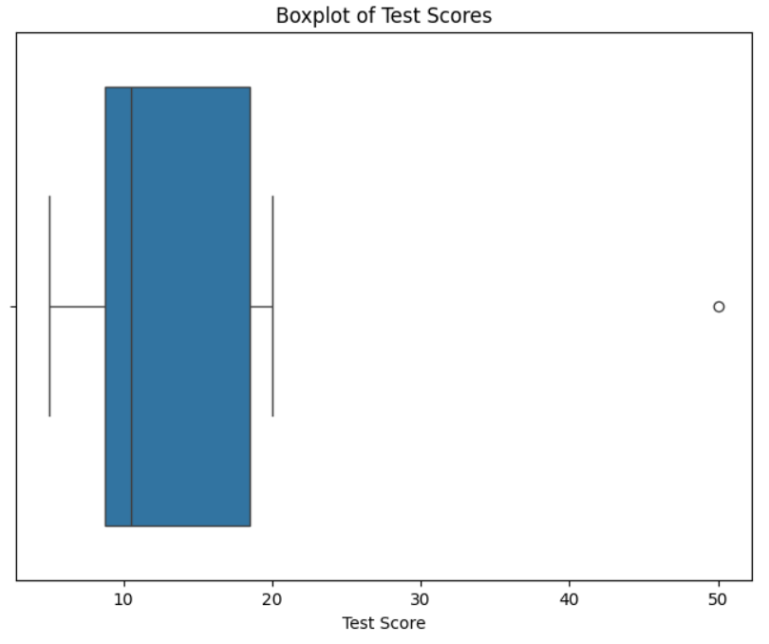

**Q] Draw the Distribution plot and cdf curve for the test score column.**

Distribution plot

| plt.figure(figsize=(8, 6))  sns.histplot(df['Test Score'], kde=True, stat="density", label='Density')  plt.title('Distribution Plot of Test Scores')  plt.show() |
| --- |

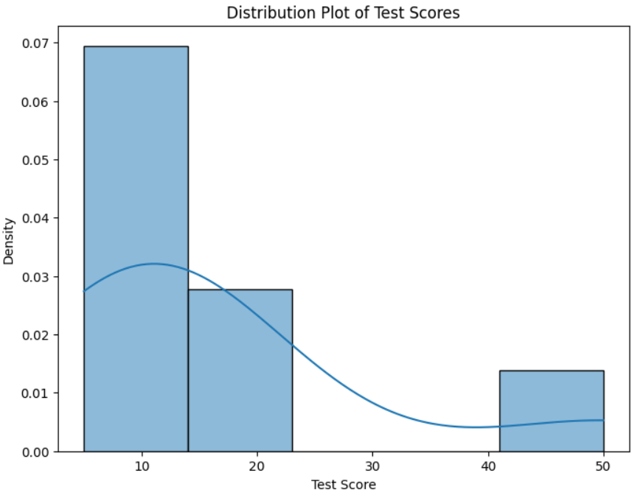

CDF Plot

| plt.figure(figsize=(8, 6))  sns.ecdfplot(df['Test Score'])  plt.title('CDF of Test Scores')  plt.show() |
| --- |

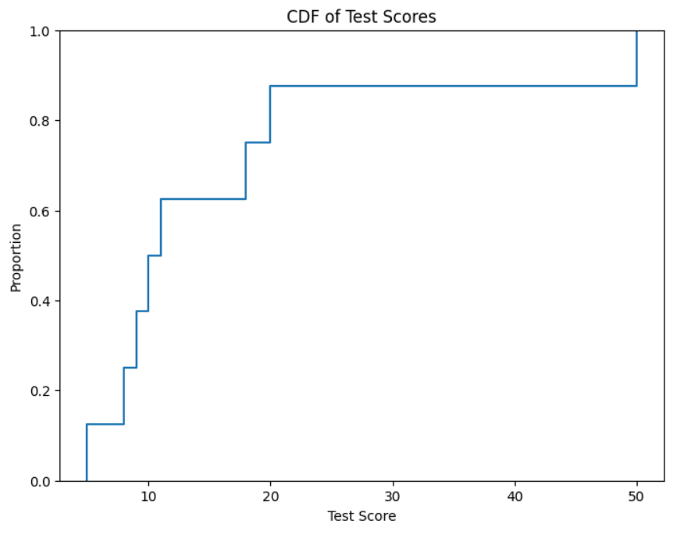

**Q] Draw the histogram for the test bad, average and best test score.**

| plt.figure(figsize=(8, 6))  sns.histplot(data=df, x='Test Score', hue='Score Category', multiple='stack')  plt.title('Histogram of Test Scores by Category')  plt.show() |
| --- |

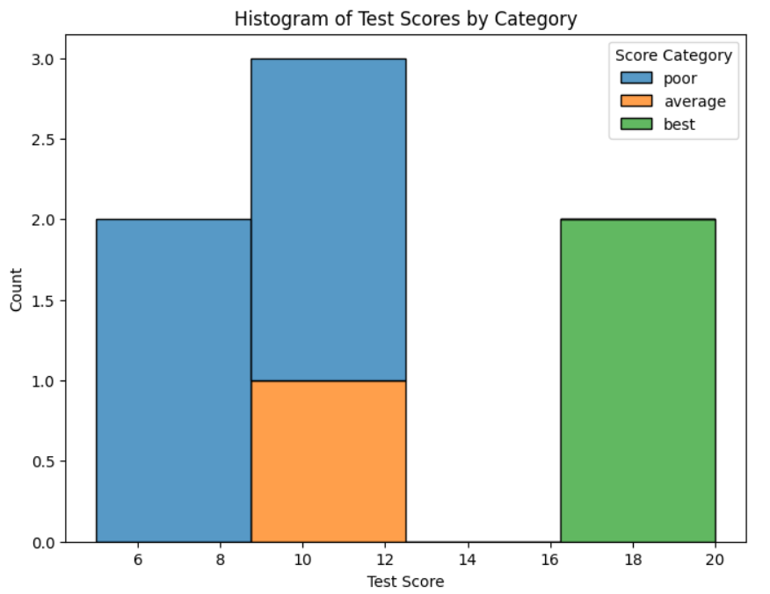

**Q] Draw the scatter plot of test scores.**

| plt.figure(figsize=(8, 6))  sns.scatterplot(x='StudID', y='Test Score', data=df)  plt.title('Scatter Plot of Test Scores')  plt.show() |
| --- |

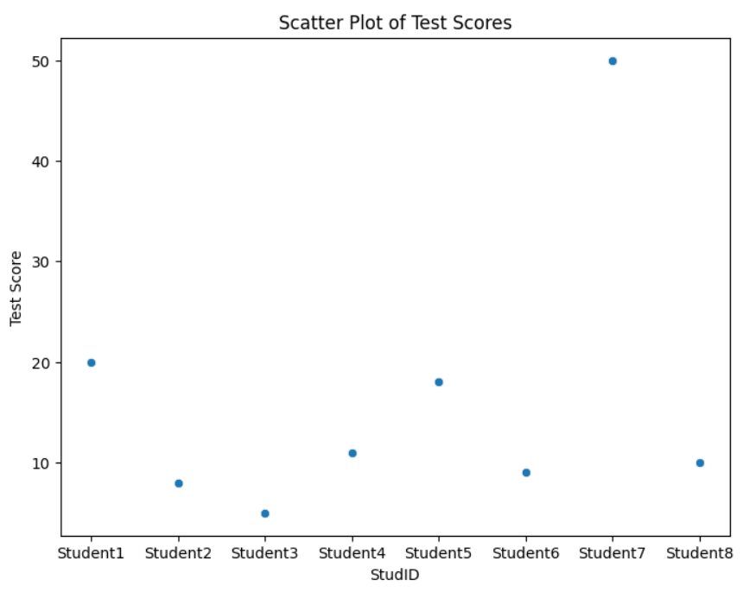

#### 

#### **Practical 5 - Retrieve Utility**

Aug 13, 2024

Dataset → [Github country code csv download link](https://github.com/Apress/practical-data-science/blob/master/VKHCG/05-DS/9999-Data/Country_Code.csv)

1. **Load the raw data of Excel/csv file**

| import pandas as pd  import os  import sys  sFileDir='D:\\MSc-IT\\Part 1\\SEM 1\\IDS\\Practicals\\Practical 5'  if not os.path.exists(sFileDir):  os.makedirs(sFileDir)  sFileName = "D:\\MSc-IT\\Part 1\\SEM 1\\IDS\\Practicals\\Practical 5\\Country_Code.csv"  print("Path : ", sFileName) |
| --- |

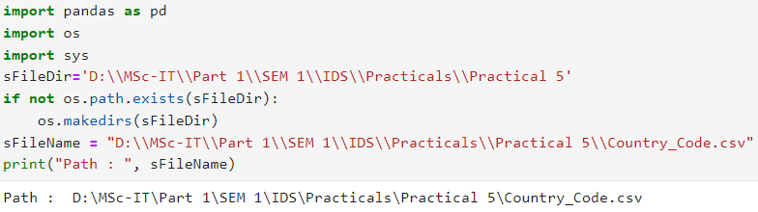

1. **Load given csv/Excel file in the pandas dataframe.**

| CurrencyData = pd.read_csv(  "D:\\MSc-IT\\Part 1\\SEM 1\\IDS\\Practicals\\Practical 5\\Country_Code.csv",  encoding='cp1252'  )  print("Data : ")  CurrencyData |
| --- |

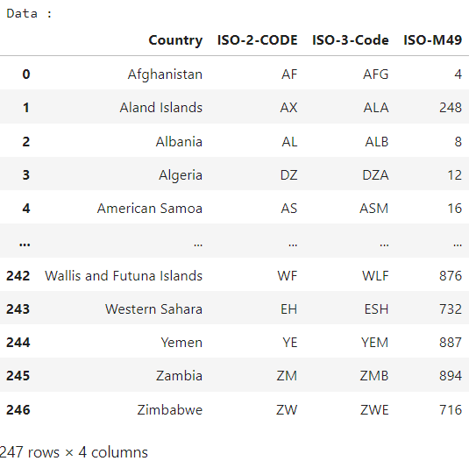

1. **Rename the columns of the dataframe.**

| CurrencyData.rename(  {'ISO-2-CODE' : 'CountryCode1', 'ISO-3-Code' : 'CountryCode2'},  axis=1,  inplace=True  )  CD = CurrencyData  print("After renaming columns : ")  CD |
| --- |

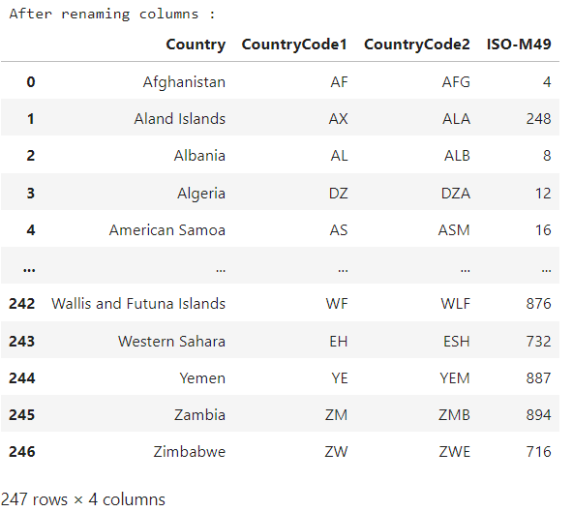

1. **Drop not required columns from the dataframe.**

| CD.drop('CountryCode1', axis=1, inplace=True)  CD |
| --- |

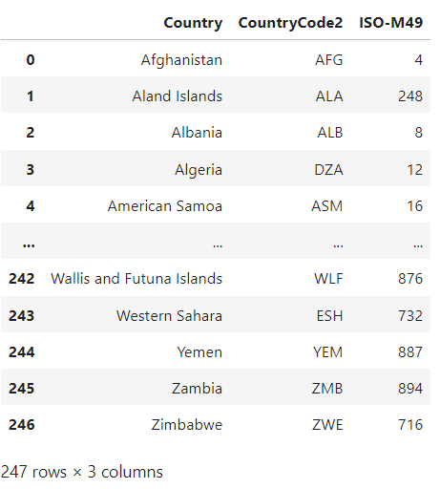

1. **Remove leading and trailing spaces of the column values.**

| CD['Country']=CD['Country'].map(lambda x:x.strip())  CD['CountryCode2']=CD['CountryCode2'].map(lambda x:x.strip())  print("After removing spaces : ")  CD |
| --- |

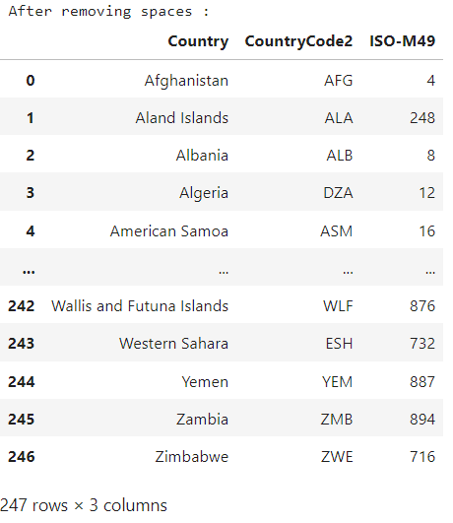

1. **Save the retrieved file in the specified folder**

| CD.to_csv("D:\\MSc-IT\\Part 1\\SEM 1\\IDS\\Practical 5\\FinalCountry_Code.csv")  print("Saved successfully!!!") |
| --- |

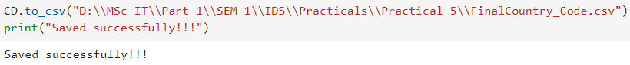

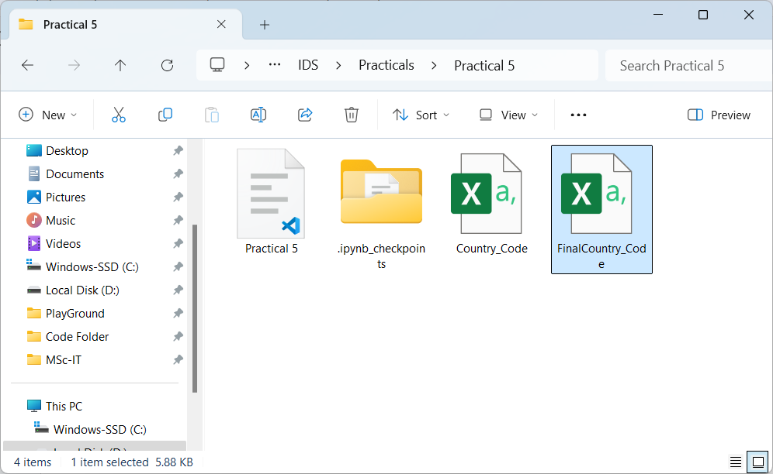

1. **Retrieve different attributes of data**

**Q] Retrieve country names from the dataframe CurrencyData.**

| print("Country names : ")  CD['Country'] |
| --- |

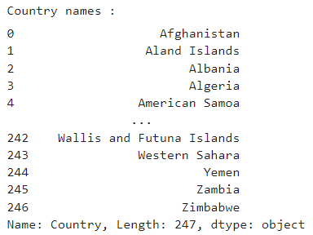

**Q] Load country names and country codes of first five countries in the variables cCode and cName from the dataframe CurrencyData.**

five=CD.head(5)

countryName=five['Country']

countryCode=five['CountryCode2']

print("Country name :")

print(countryName)

print("Country code :")

print(countryCode)

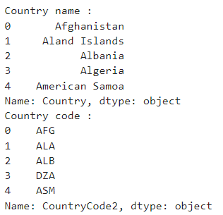

**Q] Display the country code of country Canada.**

ctr = CD[CD['Country']=='Canada']

print("Country code of Canada :",ctr.iloc[:,[1]].values)

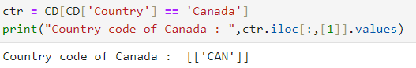

**Q] Data profile the data distribution (Skew, Histogram, Min, Max).**

| # skewness along the index axis  # Select only numeric columns  numeric_df = CD.select_dtypes(include=['number'])  # Calculate skewness for the numeric columns  skewness = numeric_df.skew(axis=0, skipna=True)  print("Skewness :")  print(skewness) |
| --- |

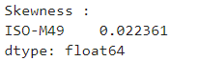

**Q] Histogram**

| CurrencyData.hist(column=’ISO-M49’) |
| --- |

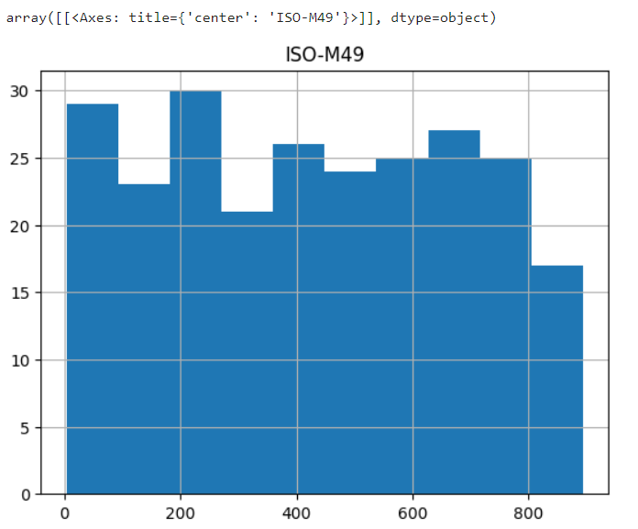

**Q] Identify any loading characteristics (Columns Names, Data Types, Volumes).**

| print("columns : ", CurrencyData.columns)  print("\nDtypes : ", CurrencyData.dtypes)  print("\nshape : ", CurrencyData.shape)  print("\nsize : ", CurrencyData.size)  print("\nmin : ", CurrencyData.min())  print("\nmax : ", CurrencyData.max()) |
| --- |

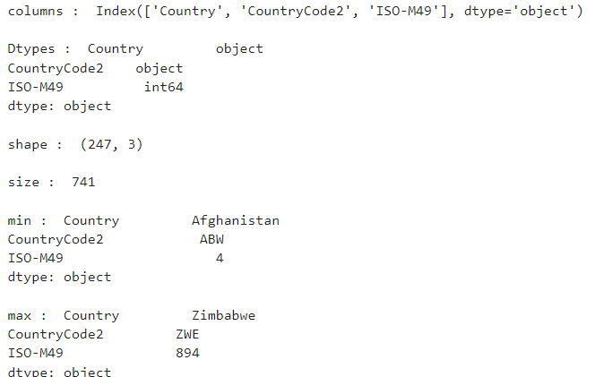

#### **Practical 6 - Access Superstep**

Aug 20, 2024

| import pandas as pd  import numpy as np  df = pd.DataFrame([  [np.nan, 2, np.nan, 0],  [3, 4, np.nan, 1],  [np.nan, np.nan, np.nan, np.nan],  [np.nan, 3, np.nan, 4]  ],  columns=list("ABCD"))  df |
| --- |

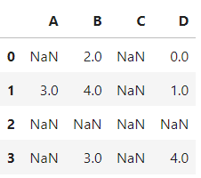

| # Dropping columns including missing value  a = df.dropna(axis = 1,how = 'any')  a |
| --- |

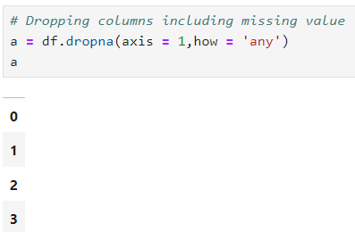

| a = df.dropna(axis=1,how='all')  a |
| --- |

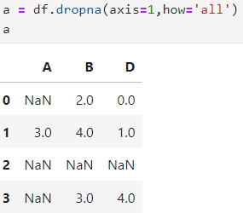

| a = df.dropna(axis=0,how='all')  a |
| --- |

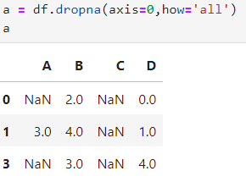

| # dropping columns including a specific number of missing values  a = df[df.isnull().sum(axis=1) <=2]  a |
| --- |

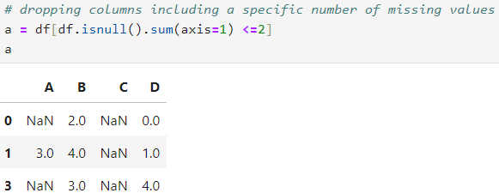

| # Number of missing values in each row  a = df.isnull().sum()  a |
| --- |

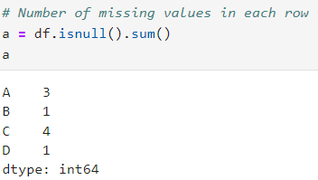

| # replacing missing values with basic measures values like mean, median etc.  a = df.fillna(df.mean())  a |
| --- |

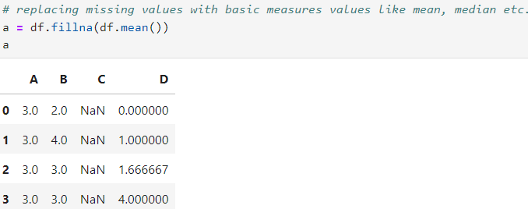

| a = df.fillna(df.median())  a |
| --- |

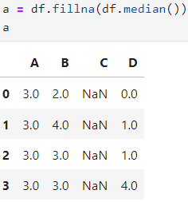

| a = df.fillna(df.mode().iloc[0])  a |
| --- |

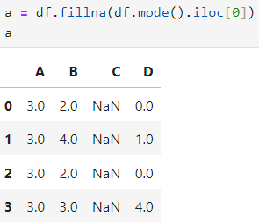

#### **Practical 7 - Processing Data.**

Aug 20, 2024

#### **Practical 8 - Data Visualization.**

Aug 20, 2024

**Bar Chart**

| import matplotlib.pyplot as plt  fig, graph = plt.subplots()  fruits = ['grapes','blueberry','apple','blue berry', 'Orange']  counts = [ 49, 25, 55, 14, 44]  fruit_colors = ['green', 'purple', 'red', 'blue', 'orange']  graph.bar(fruits, counts, label = fruit_colors, color = fruit_colors)  graph.set_xlabel('Fruits')  graph.set_ylabel('Supply (in KGs)')  graph.set_title('Fruit supply in Quantity')  graph.legend(title='Color to Fruits')  plt.show() |
| --- |

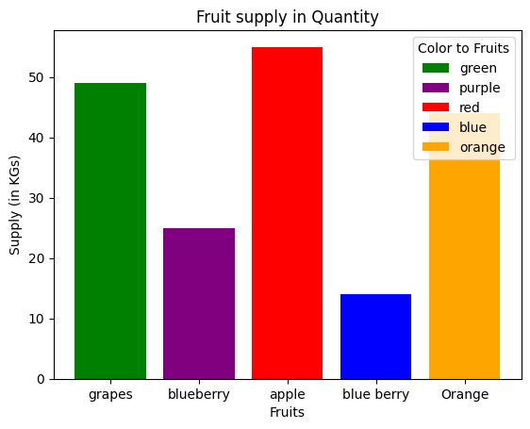

#### 

**Pie Chart**

| labels = 'Frogs', 'Hogs', 'Dogs', 'Logs'  sizes = [15,30,45,10]  fig, ax = plt.subplots()  ax.pie(sizes, labels=labels) |
| --- |

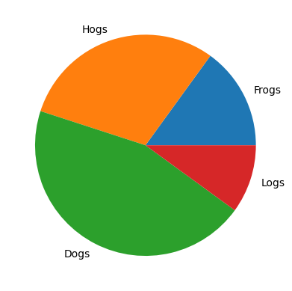

| labels = 'IT', 'HR', 'Sales', 'Marketing'  sizes = [20, 10, 40, 30] # Percentage of employees in each department  colors = ['#ff9999','#66b3ff','#99ff99','#ffcc99'] # Custom colors  explode = (0, 0, 0.1, 0) # "explode" the 3rd slice (Sales)  fig, ax = plt.subplots()  ax.pie(sizes, labels=labels, colors=colors, explode=explode, autopct='%1.1f%%', shadow=True, startangle=90)  ax.axis('equal')  plt.show() |
| --- |

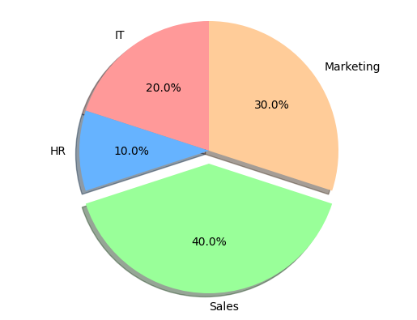

**Line Chart**

| import numpy as np  t = np.arange(0.0, 2.0, 0.01)  s = 1 + np.sin(2 * np.pi * t)  fig, ax = plt.subplots()  ax.plot(t, s)  ax.set(xlabel='time (s)', ylabel='voltage (mV)', title='About as simple as it gets, folks')  ax.grid()  fig.savefig("D:\\MSc-IT\\Part 1\\SEM 1\\IDS\\Practicals\\Practical 8\\pie_img.png")  plt.show() |
| --- |

#### 

#### 

#### **Practical 9 - Data Analysis using Excel**

Aug 20, 2024

Create an excel sheet

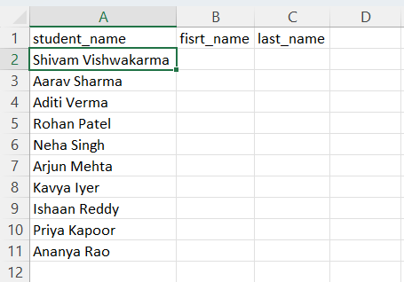

Select the values from Student Name column → Data tab → Text to Columns → Click Next

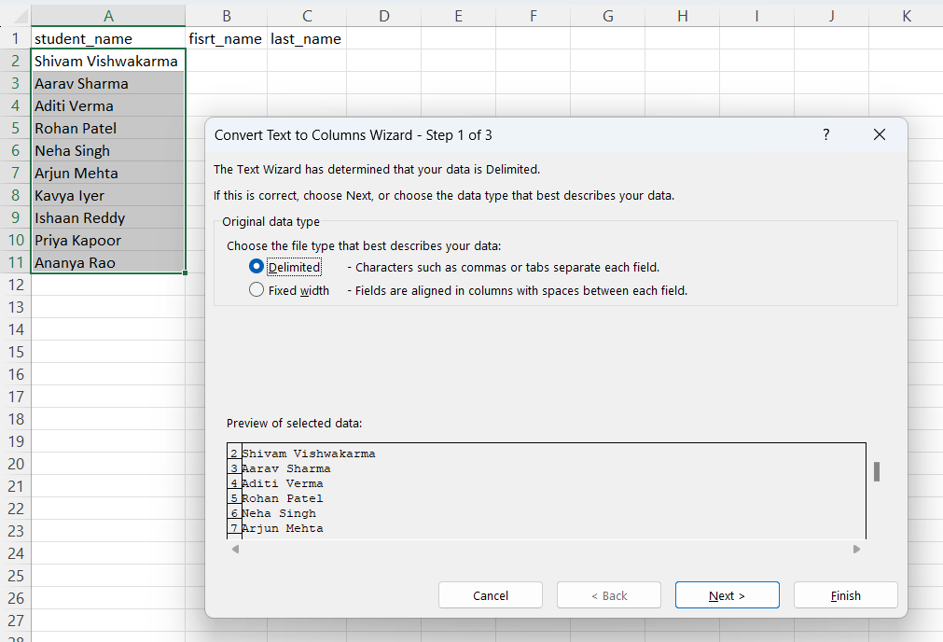

Click Next

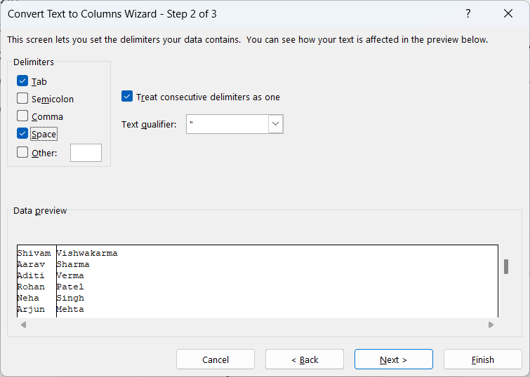

Click arrow to select destination cell

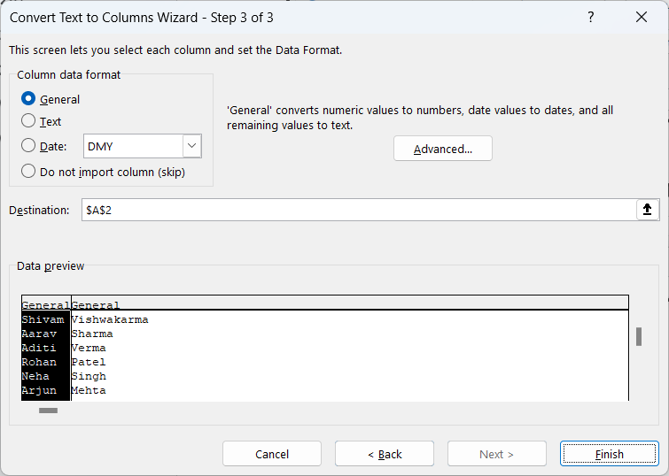

Select $B$2 → Click down arrow

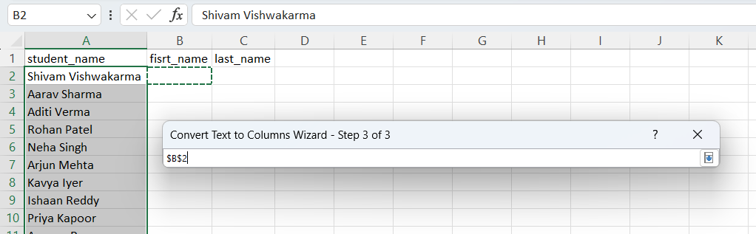

Select Text → Click Finish

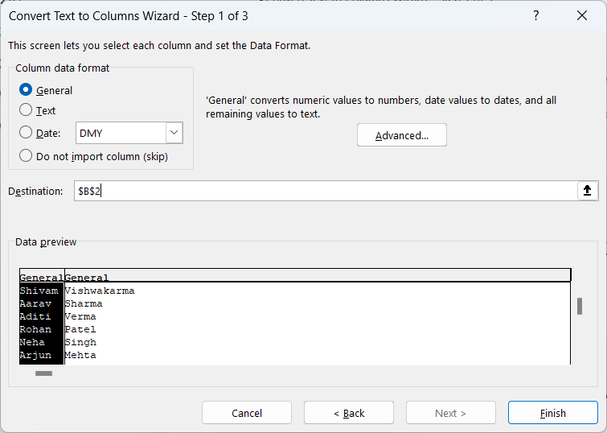

Output

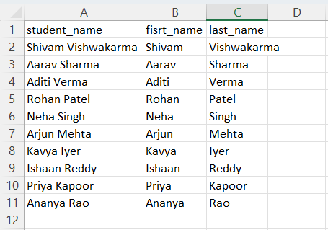

Create Q1 columns having A, B and C as sub columns → CreateTotal Q1 column for sum value

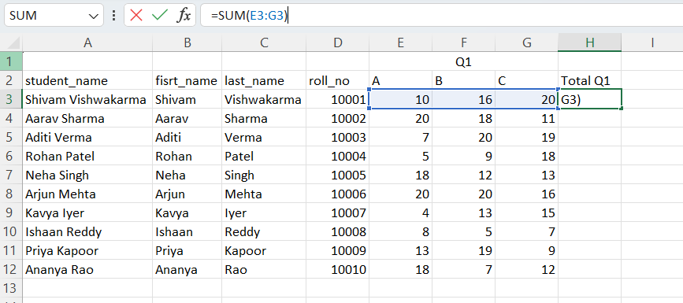

Result

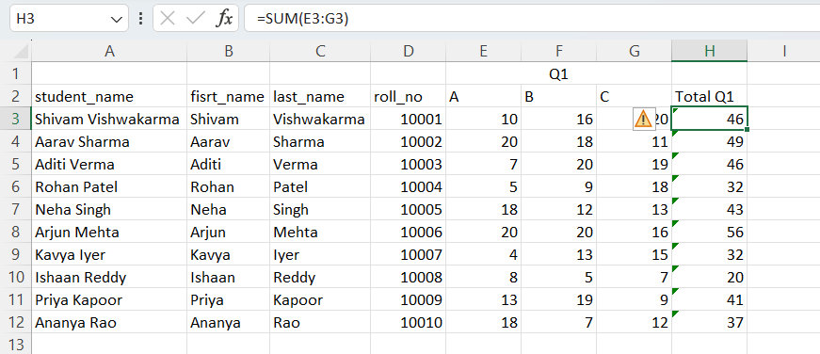

Similarly create a Q2 and Total Q2 columns

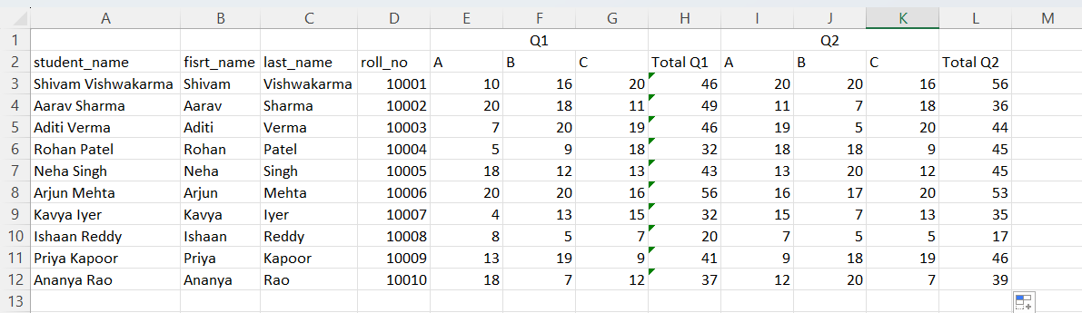

Create a column named Average for calculating average value of Q1 and Q2

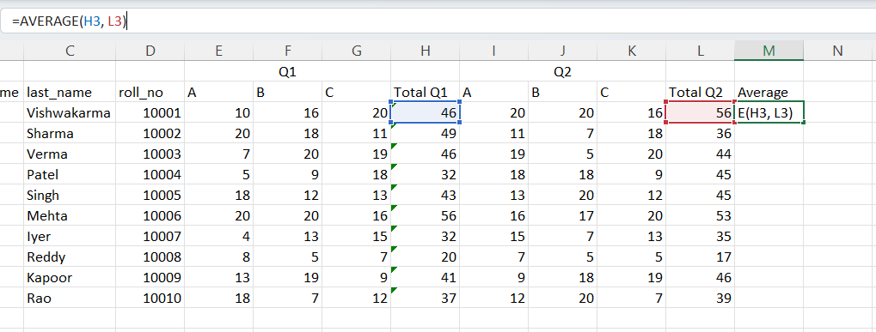

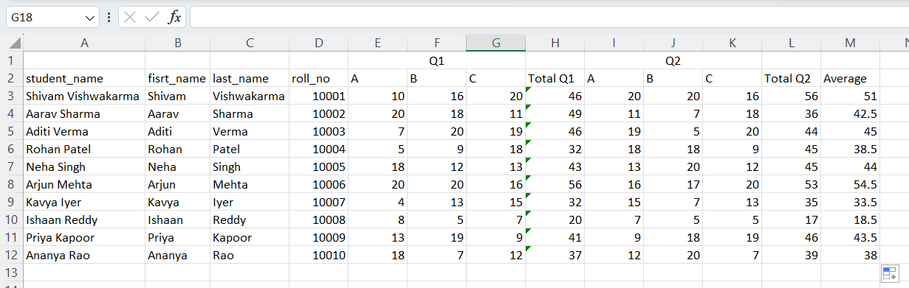

Apply Conditional Formatting (Less than 10) on values of Q1

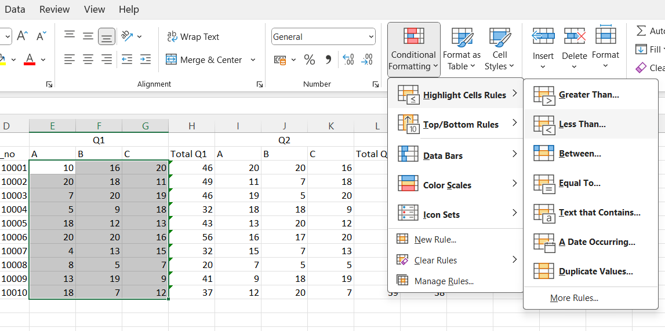

Enter a value → Click OK

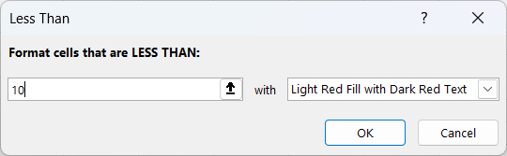

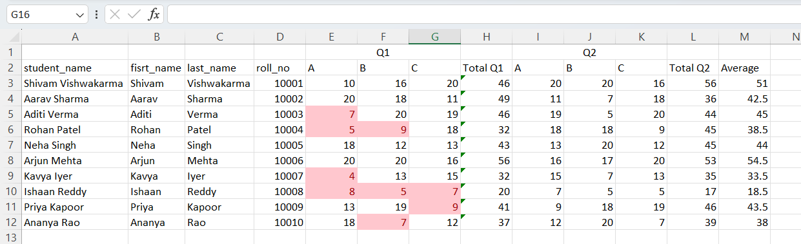

Similarly apply Greater than 15 rule on same values

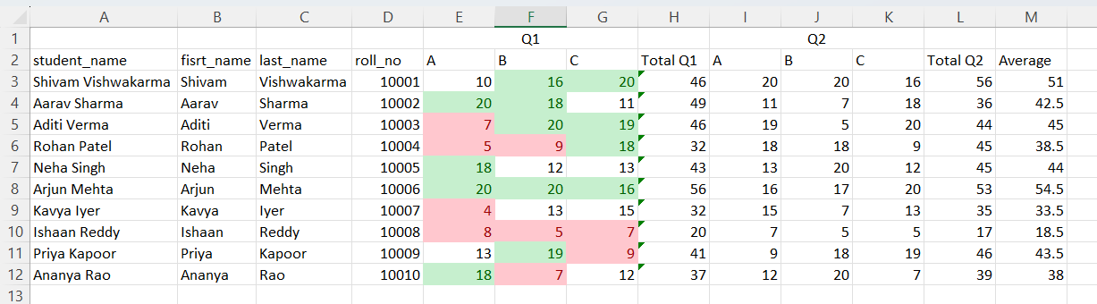

Do the same thing on values of Q2

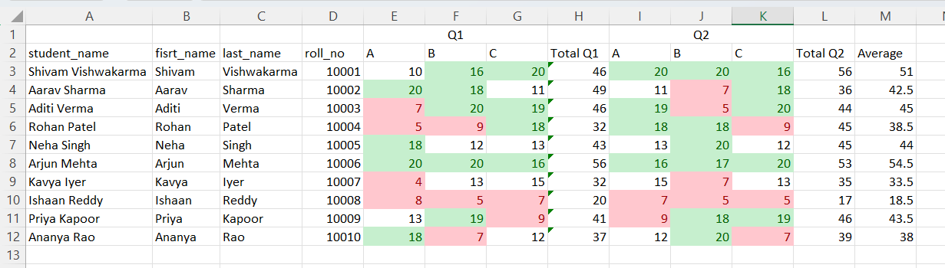

Select values of Total Q1 → Home tab → Conditional Formatting → Icon Sets (any desirable icon set)

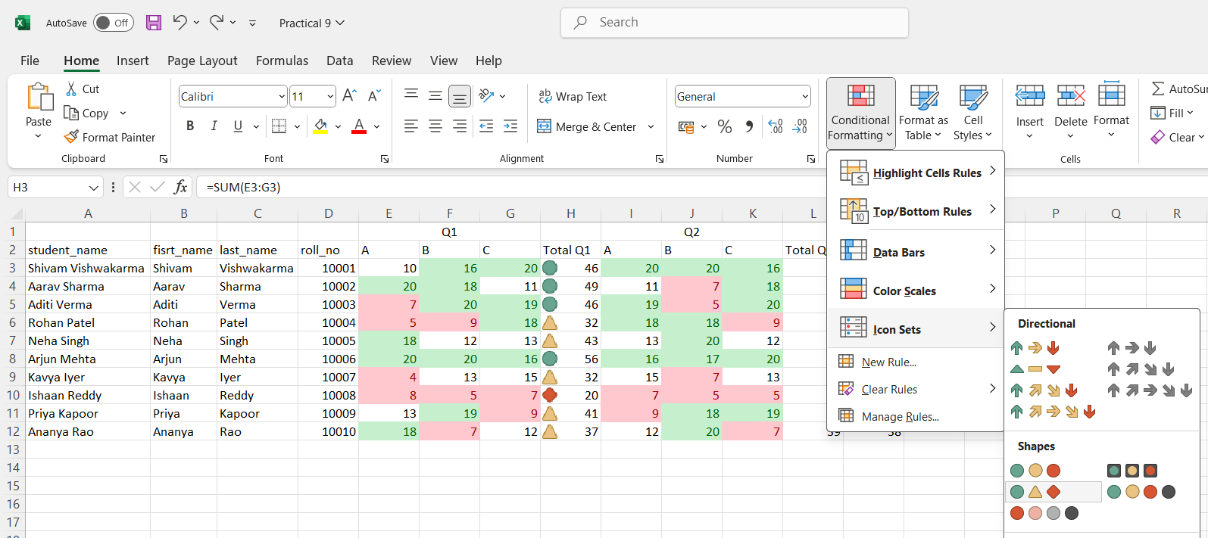

Similarly on Total Q2 and for Average column as well

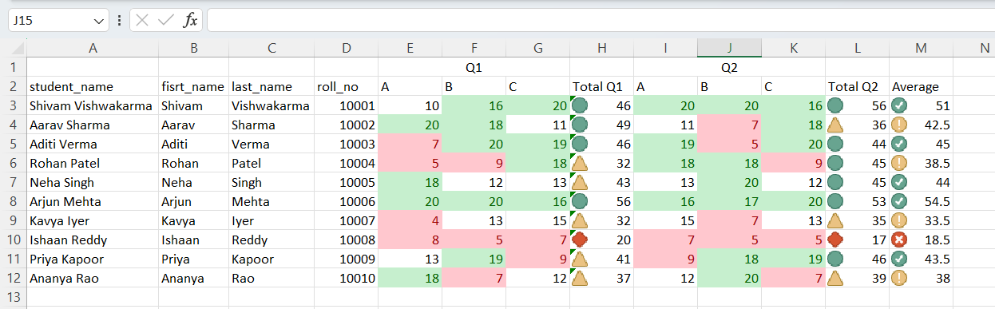

Select values of the Average column → Conditional Formatting (Home tab) → Click Manage Rules

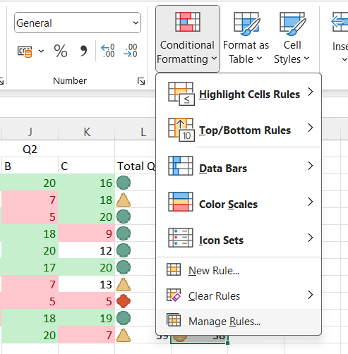

You can also edit from here

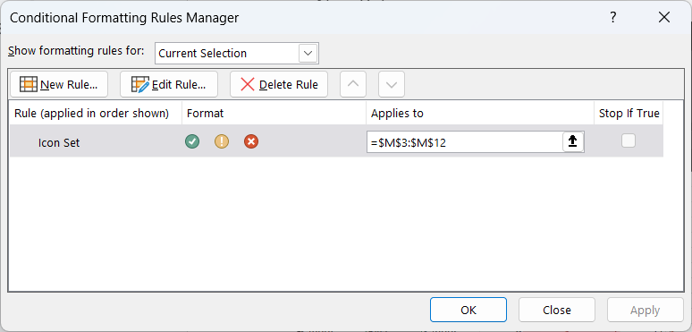

Select values of fisrt_name → Conditional Formatting (Home) → Manage rules → New Rule

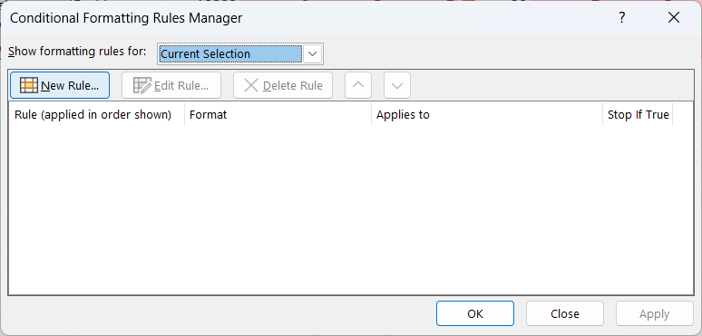

Select “Format only unique or duplicate values” and select unique from dropdown and click Format

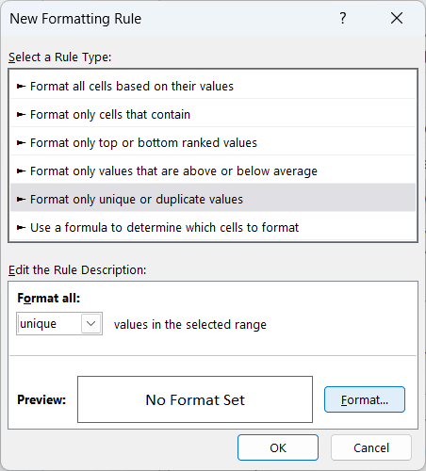

Make changes as you want → Click OK [i will like to make unique value to style in italic only]

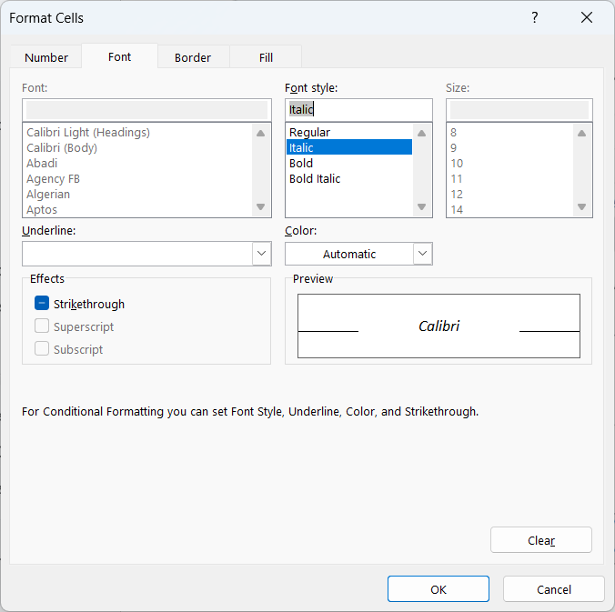

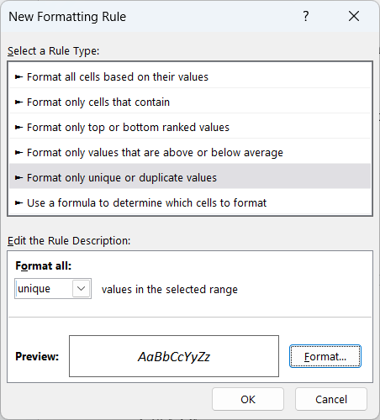

Click Apply → Click OK

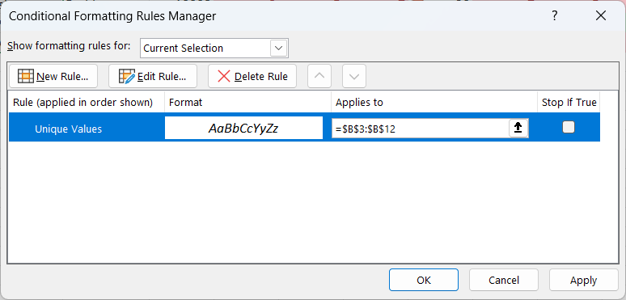

Result [As all first_nme were unique only hence all value in frist_name is now styled italic]

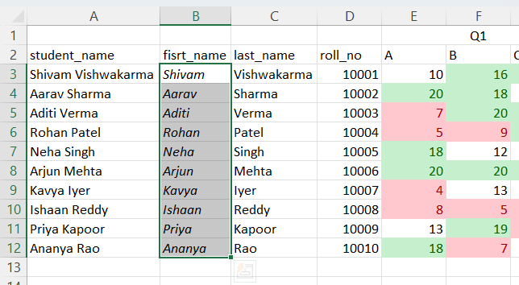

Select roll_no and average column and go to → Insert tab → Recommended charts and select whatever chart you like

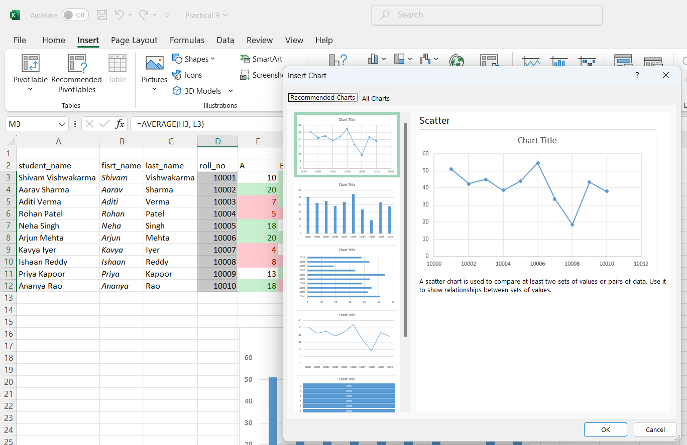

Bar chart for Roll no and Average

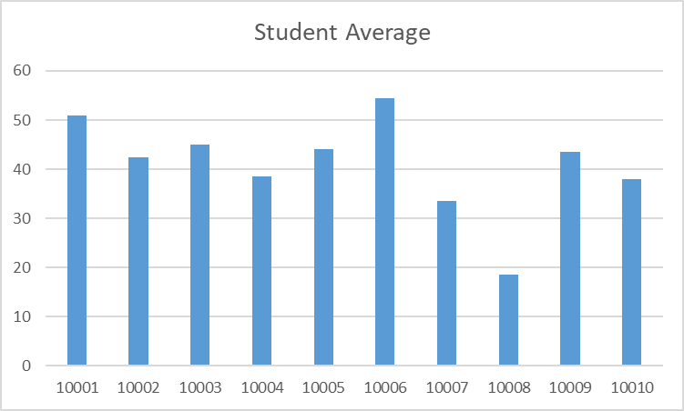

Line chart for Roll no and Average

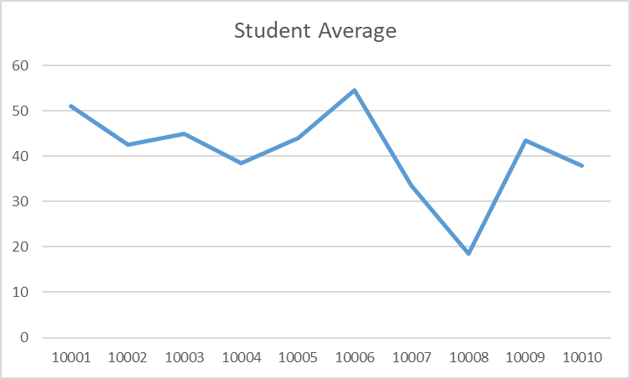

You can design the charts as per your requirement from chart design tab which is enabled after clicking on a chart

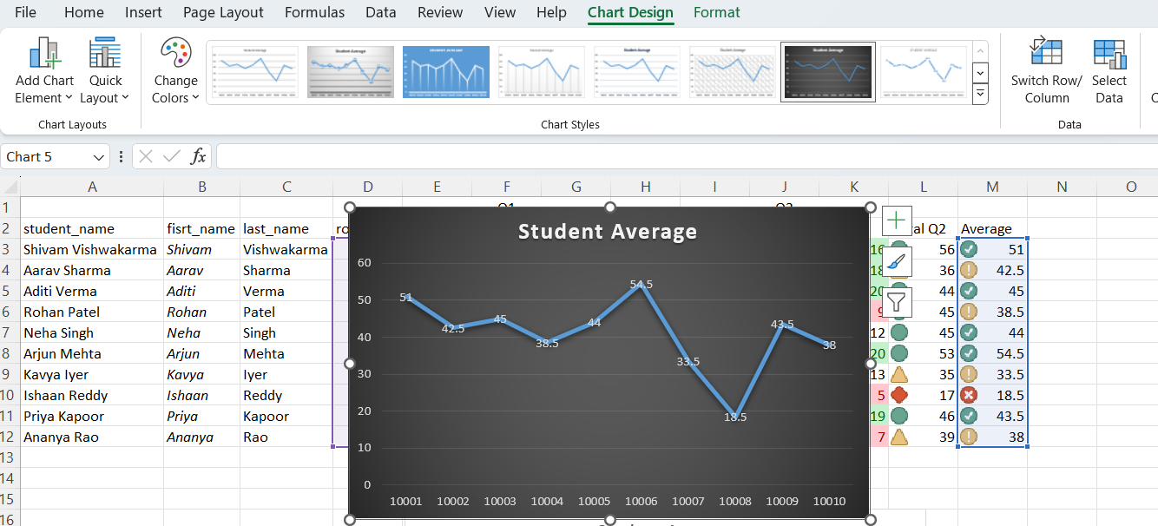

**Employee data csv file :**

<https://gist.github.com/kevin336/acbb2271e66c10a5b73aacf82ca82784>

Open the csv file

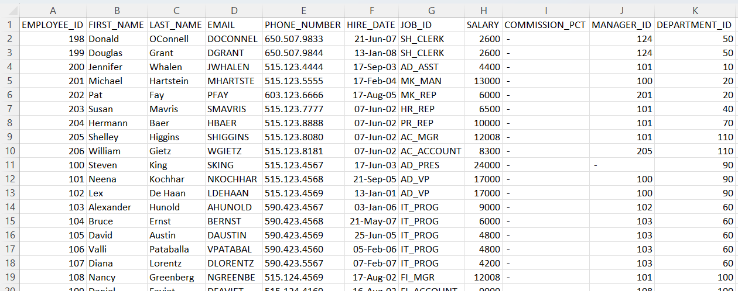

1. Total employee

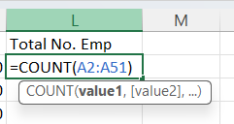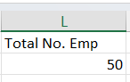

2. List the Emp with region code 650

Select PHONE_NUMBER column values and go to → Data tab → Text to Columns option and click on NEXT

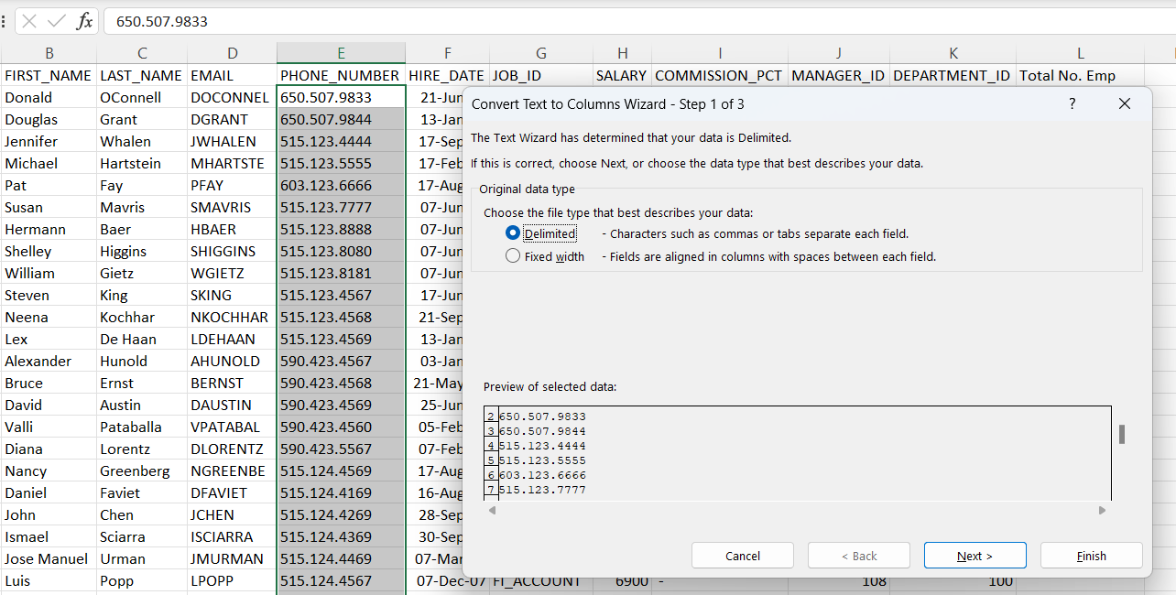

Enter dot in Other

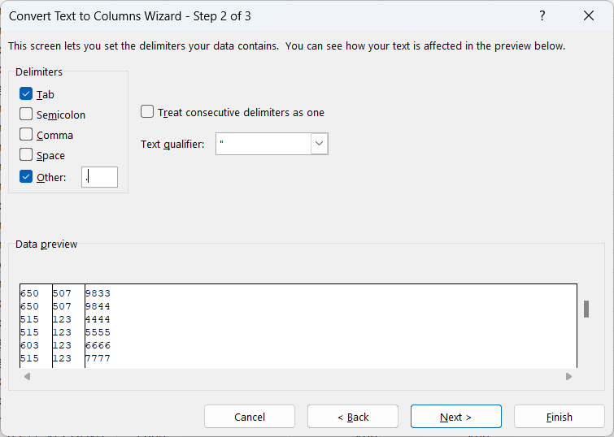

Enter destination and click on Finish

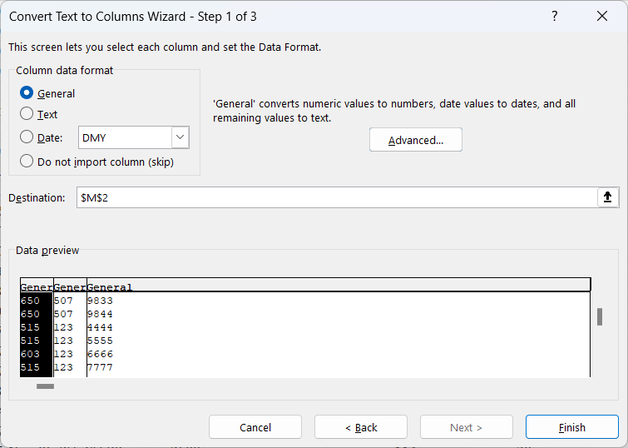

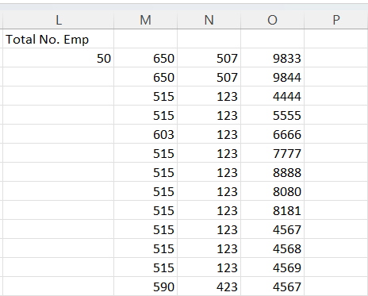

Give the column name as Region code

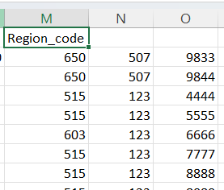

Select values of Region_code column → Right click → Filter → Filter by Selected Cell’s Value

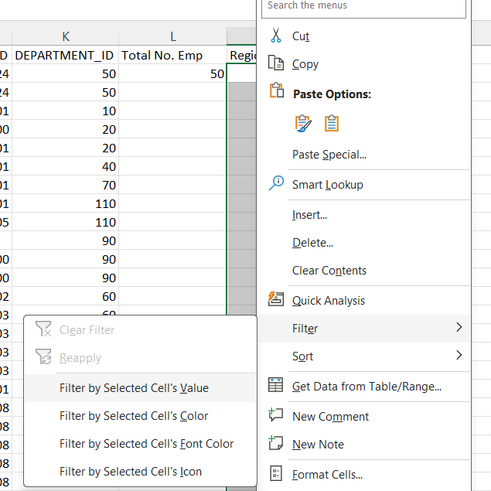

Click on Filter icon → Select 650 → Click OK

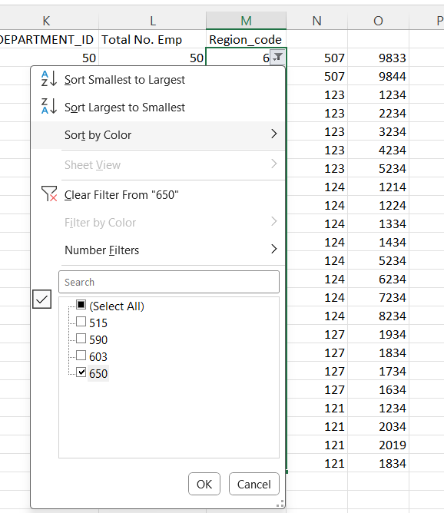

Results

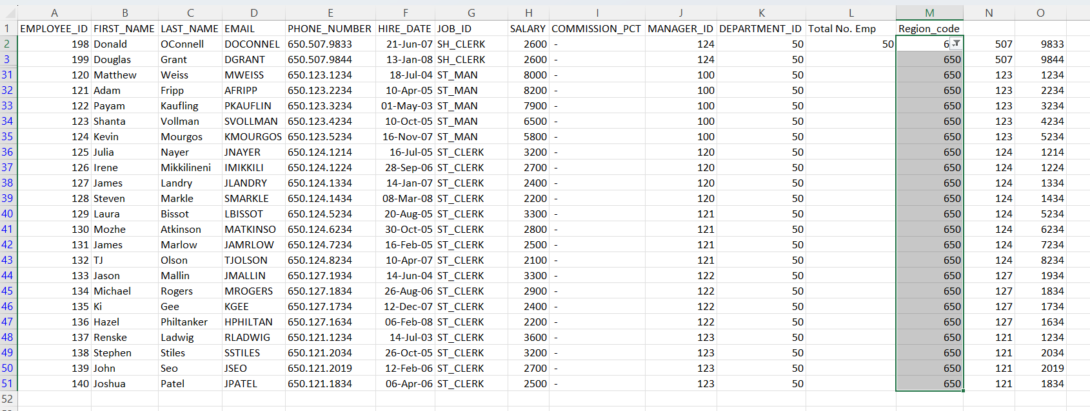

3. Highlight the emp with the joining date as 7 june 2002

Do the following steps

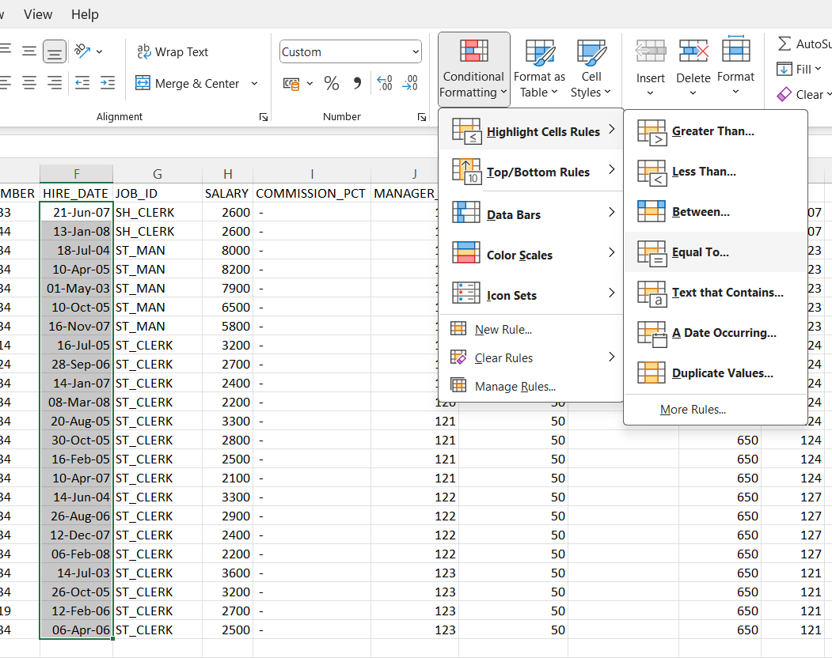

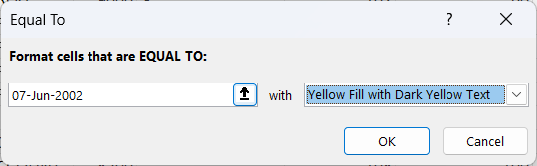

Results:

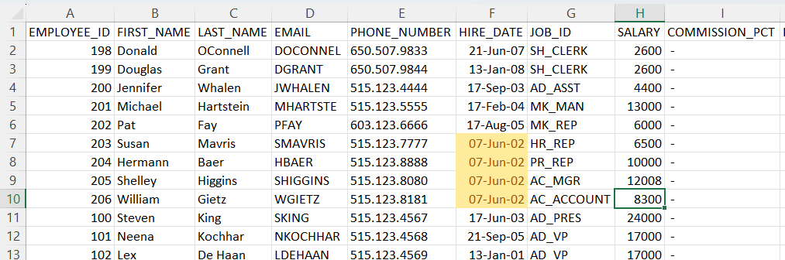

4. Get year wise salary trend

Create a new column Year

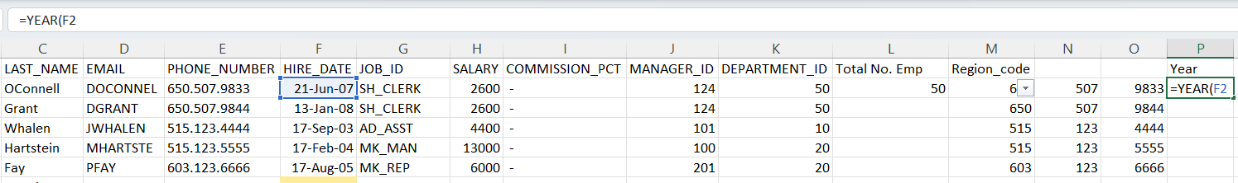

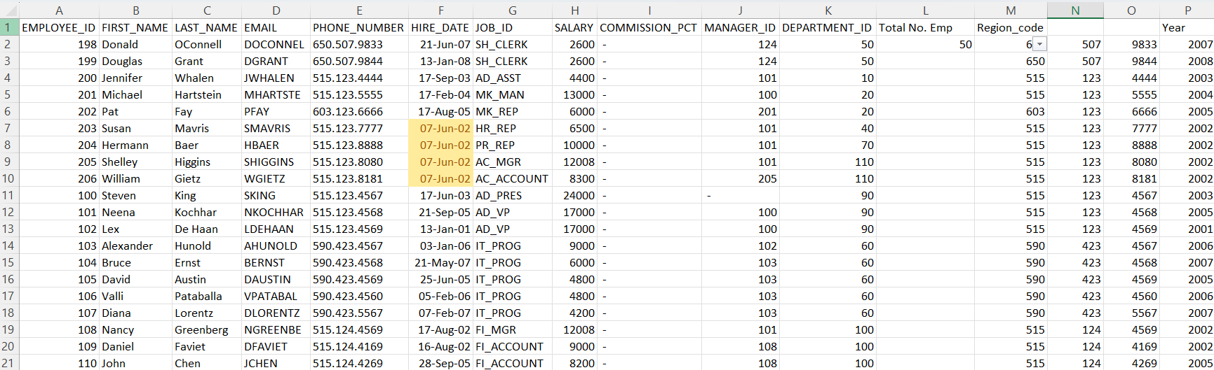

Select entire sheet → Insert tab → Pivot Table → From Table/Range

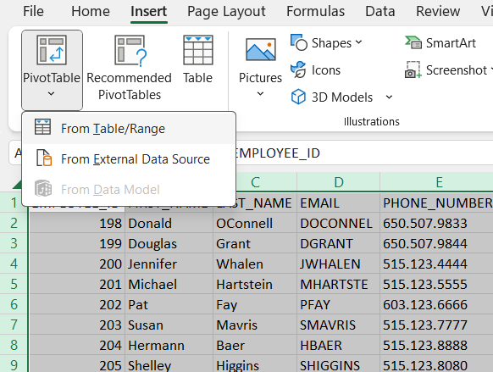

Click OK and new sheet will open

Drag Year column to rows and Salary column to Values

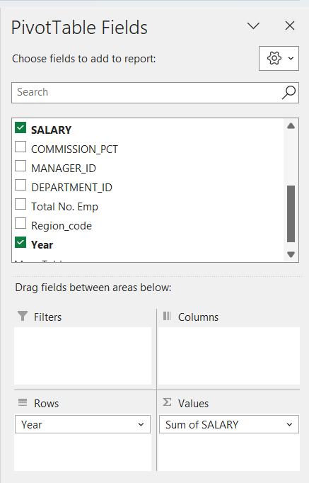

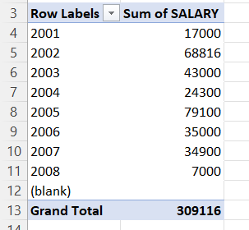

5. List Designations with Highest and Lowest Salary

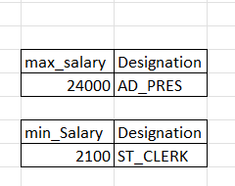

Column H is Salary and G is Job_id

=MAX(H2:H51)

=INDEX(G2:G51, MATCH(MAX(H2:H51), H2:H51, 0))

=MIN(H2:H51)

=INDEX(G2:G51, MATCH(MIN(H2:H51), H2:H51, 0))

6. List emp who are working under manager with manager id 114

Do the following steps (similar to steps of filter)

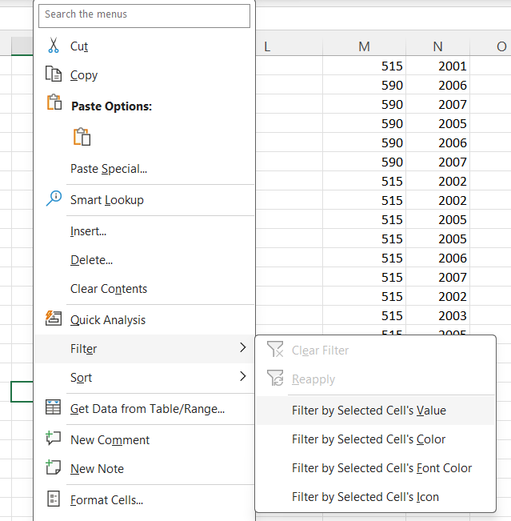

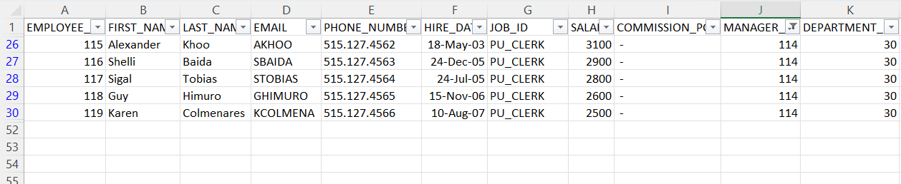

7. Count Employees in Each Department

Drag Department_ID in rows and Count of Employee_ID in values

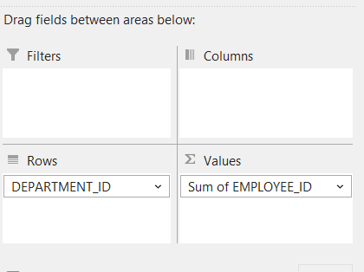

Change Sum to count

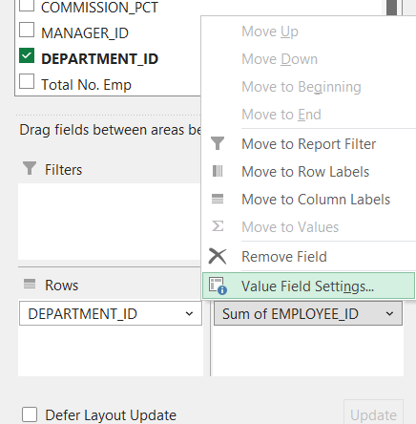

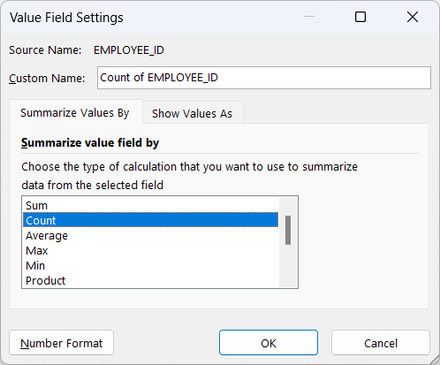

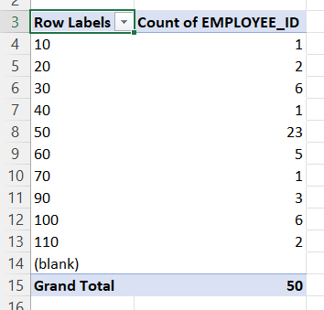

8. Plot Employees of Each Department in a Pie Chart

Select Pivot table → Insert tab → Pie chart

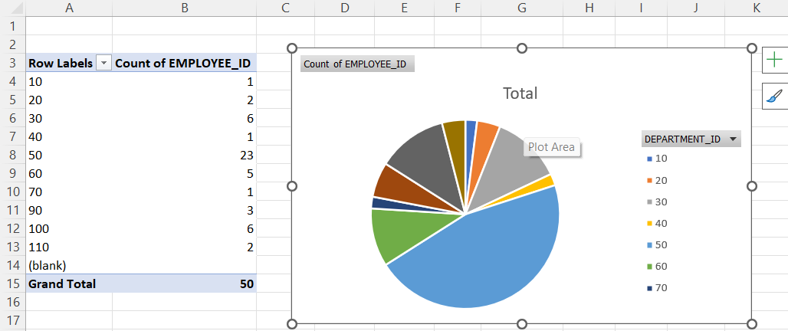

9. Display all salaries with the data.

Displaying whole data without any filter or formatting

